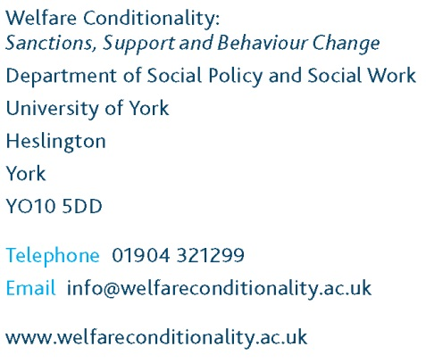

Written evidence from the Welfare Conditionality: Sanctions, Support and Behaviour Change Project

Submission to Work and Pensions Select Committee inquiry:
Benefit sanctions policy beyond the Oakley review

December 2014

1 Executive summary

1.1 Our five-year (2013-2018) ESRC funded project Welfare conditionality: sanctions support and behaviour change, involving researchers from six universities, is exploring the ethics and effectiveness of welfare conditionality. We are particularly investigating the effects of sanctions and support on the lives of nine groups: unemployed people, those claiming Universal Credit, lone parents, disabled people, social tenants, homeless people, individuals/families subject to antisocial behaviour orders/family intervention projects, offenders and migrants.

1.2 There has been a substantial escalation in the use of JSA sanctions. The evidence suggests that those with specific vulnerabilities and complex needs, such as homeless people, lone parents and disabled people, have been disproportionately affected by intensifying welfare conditionality. Young people are more severely affected by the rapid growth in benefit sanctions than other age groups, though the reasons for the disproportionate risk of sanctioning they face are not yet clear. There is now a discernible upward trend in both the number and rate of ESA claimants who are sanctioned.

1.4 Although conditionality is currently embedded in a broad range of policy arenas and its use has been extended over time to previously exempt groups (eg, lone parents with children younger than 12, disabled people), policy-makers’ assumptions about conditionality and its effects remain largely untested. Our own research seeks to answer detailed questions about how the system works in practice, which groups are affected, why and how.

1.5 International evidence on conditionality reviewed in the first phase of the study indicates that benefit sanctions (especially severe sanctions) substantially raise exits from benefits, and may also increase short-term job entry; but the longer-term outcomes for earnings, job quality and employment retention appear unfavourable. In particular, concerns remain about the destinations of those who exit benefits, and whether increasing numbers are becoming ‘disconnected’ from both work and welfare. There are also concerns about unintended (and less intended) consequences of conditionality, particularly the hardship faced by those excluded from benefits, services and/or support as a result of failing to meet behavioural requirements.

1.6 We recommend further exploration of alternative models that might ease the effects of sanctions, and/or give incentives and support to help claimants into training and work.

2 Introduction

2.1 Our project Welfare conditionality: sanctions support and behaviour change is a five year (2013-2018) programme of research funded by the Economic and Social Research Council. It brings together researchers working in six English and Scottish Universities - University of Glasgow, Heriot-Watt University, University of Salford, Sheffield Hallam University, University of Sheffield and the University of York, which acts as the hub for this partnership.

2.2 We are exploring two key questions linked to the effectiveness and the ethics of welfare conditionality:
- First, how effective is welfare conditionality in changing the behaviour of those in receipt of welfare benefits and services?
- Second, are there any particular circumstances in which the use of conditionality may, or may not be, justifiable?

2.3 Our research involves interviews with people from nine cities and towns in England and Scotland (Bath, Bristol, Edinburgh, Glasgow, Inverness, London, Manchester, Peterborough, and Sheffield) who experience varying types and degrees of welfare conditionality in their everyday lives. The focus is on nine particular groups: unemployed people, those claiming Universal Credit, lone parents, disabled people, social tenants, homeless people, individuals/families subject to antisocial behaviour orders/family intervention projects, offenders and migrants. Our briefing papers available at http://www.welfareconditionality.ac.uk/category/publications/ offer further discussion of issues in relation to conditionality and these groups. We are conducting three waves of repeat qualitative longitudinal interviews over a two year period with 400 participants subject to welfare conditionality, to establish the longer term effects of the sanctions/support they experience. Our final report will be published in early 2018. For this reason we cannot offer definitive information on the effects of sanctions at this stage. However, our extensive review of existing literature on this topic does offer some evidence from the UK and abroad, and we summarise relevant findings here. The evidence offered here in summary is available in more detail, with full references, in the Round Up drawing on the first phase of the project published by the Joseph Rowntree Foundation at: http://www.jrf.org.uk/sites/files/jrf/Welfare-conditionality-UK-Summary.pdf. Our evidence in this submission follows the order of the committee’s areas of interest and questions.

3 Employment and Support Allowance (ESA) sanctions, including: whether the current ESA sanctions regime is appropriate and proportionate for jobseekers with ill health and disabilities; and the reasons for recent sharp increases in the number of ESA sanctions
Whether particular groups of ESA and JSA claimants (by impairment type; age; gender etc.) are proportionately more likely to be sanctioned than others
3.1 Findings from our review of UK and international evidence suggest that the distribution of welfare sanctions varies among different groups, and that some groups are particularly affected.

3.2 There has been a substantial escalation in the JSA sanctions, and growing concerns about the impact of these on vulnerable groups, specifically those experiencing homelessness, lone parents and disabled people. Indeed, government recognition of this has prompted an easing of work requirements for some recently homeless JSA claimants, as long as they take reasonable steps to find accommodation. The DWP is also piloting a scheme to help vulnerable homeless people access Jobcentre Plus support and avoid sanctions. This action at policy level is welcome.

3.3 Some minority ethnic groups may also be disproportionately sanctioned, which could reflect issues around language, understanding and communication.

3.4 The Oakley review identified particular difficulties faced by the most vulnerable claimants (eg, those with limited understanding of English or learning disabilities). Advisers involved in the review identified “a ‘vulnerable’ group who tended to be sanctioned more than the others because they struggled to navigate the system”.

3.5 However, what is most clear from the available UK statistical evidence is that young people are more severely affected by the rapid growth in benefit sanctions than other age groups. As Figure 1 indicates, the recent escalation of sanction rates applies to all age groups. But the under-25 group has had a consistently higher sanction rate than other age groups, and individuals in this group account for 41 per cent of all sanctions issued under the new regime from October 2012 to December 2013 (Figure 2). This confirms that sanctioning is now a significant risk for an under-25 JSA claimant, affecting 8 per cent of claimants in this age group per month in 2010–11 (averaged over this financial year), and rising to 8.4 per cent in 2013–14 (part-year).

3.6 There is now a discernible upward trend in both the number and rate of ESA claimants who are sanctioned. The rate of sanctions for ESA WRAG claimants has risen from a low of 0.08 per cent per month in June 2011 (before reconsiderations and appeals), to 1.16 per cent in June 2014. After reconsiderations and appeals, this amounted to 5,132 ESA sanctions in June 2014, the highest monthly figure since sanctions were introduced for this group in 2008.

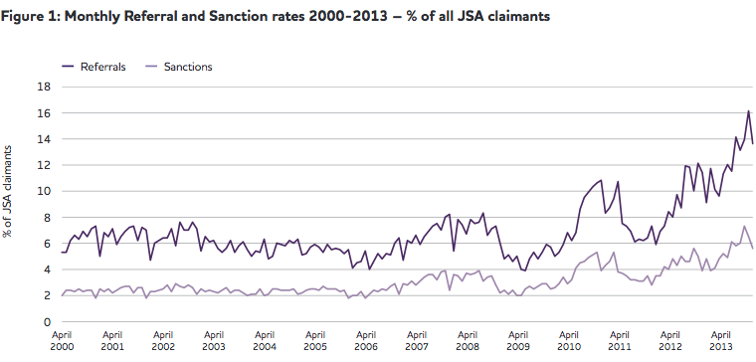

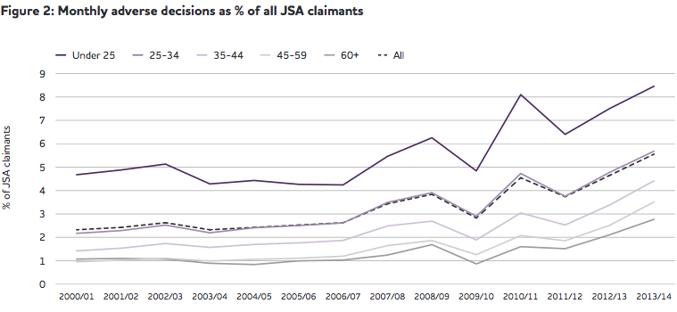

4 To follow up the Committee's recommendation for a full independent review, to investigate the purpose, effects and efficacy of benefit sanctions, and to consider the issues such a review would need to take into account

4.1 In the UK the use of conditional welfare arrangements that combine elements of sanction and support which aim to 'correct' the 'problematic' behaviour of certain welfare recipients is now an established part of the welfare, housing and criminal justice systems. A strong mainstream political consensus exists in favour of conditionality and it is currently embedded in a broad range of policy arenas. Its use has been extended to cover groups that were previously, largely, exempted from job search and training activities (eg, lone parents and disabled benefit recipients). Simultaneously, the sanction regime has been intensified.

4.2 However, policy-makers’ assumptions about conditionality and its effects remain largely untested. Our own research is examining a series of key questions that we believe have relevance to the committee’s inquiries. They include:
• How effective is conditionality in promoting and sustaining behaviour change over time among diverse groups of welfare recipients?
• How might conditionality be used to bring about positive behavioural change and ensure more effective support to some of the most vulnerable groups in society?
• What are the ethical and practical implications of making access to welfare and housing support conditional on behaviour?
• Can sanctions which lead to the reduction or removal of welfare and housing support be ethically justified if such measures achieve positive behavioural change? If so, in which circumstances?
• What forms of support and engagement are required to bring about and sustain behavioural change in differing welfare contexts?
• What are the immediate and longer term impacts of sanctions and/or packages of support on individuals' behaviour, circumstances and opportunities?
• In which ways do frontline welfare practitioners understand, justify and implement conditionality and what are the effects of any differentiation in approaches?
• To what extent do age, gender, ethnicity, disability and social class mediate the effects of conditionality in promoting and sustaining behaviour change?
• How, if at all, do the differing legislative frameworks that exist in England and Scotland affect the implementation, and experiences, of conditionality?

5 What are the current sanctions regimes trying to achieve and what evidence is there that they work?
- To what extent are sanctions justified solely as a means of ensuring that unemployed benefit claimants fulfil the conditions of benefit entitlement?

5.1 Welfare recipients are subject to various forms of ‘conditions’ when accessing state support. The committee’s questions relate to conditions of conduct (or behavioural conditions). While some would argue that the ‘punishment’ of non-compliers and achieving reductions in welfare expenditure have now emerged as additional key objectives, the main stated goal of conditionality within the benefit system is to influence claimants’ behaviour by incentivising them to actively seek work and move off benefits.

5.2 The scope and scale of behavioural forms of conditionality, as well as the
severity of the sanctions applied for failure to comply with the required conduct (eg, attending appointments with employment advisers), has increased substantially since the 1980s. Some particular groups - notably lone parents, disabled people, offenders and some categories of migrants - have also been targeted for specific conditionality measures. For example, offenders now enter the Work Programme from ‘day one’ of their prison release, rather than 9 or 12 months after starting claiming JSA. Newly arrived EEA ‘jobseeker’ nationals face a minimum earnings threshold, a ‘genuine prospect of work’ test and restrictions on entitlement to Housing Benefit, Child Benefit and Child Tax Credit.

5.3 Our review of a wide range of evidence from the UK and abroad has drawn these preliminary conclusions on the effects of this type of conditionality:
- Sanction-backed conditionality regimes do seem to reduce benefit use by both lowering benefit take-up and speeding up benefit exit, as has been most dramatically illustrated in the case of the US. But concerns remain about the destinations of those who exit benefits, and in particular about whether increasing numbers are becoming ‘disconnected’ from both work and welfare.
- There is some European evidence (though little that is UK-specific) that benefit sanctions can shorten periods of unemployment and raise short-term job entry rates, but the evidence available on their longer-term impacts is much more limited, and on balance negative, suggesting that benefit sanctions may lower the likelihood of sustainable employment and incomes over time.
- Moreover, the current evidence base does not enable one to untangle the relative impacts of the job search conditions themselves, the sanctions regime that enforces them, and any accompanying forms of support. There is a notable lack of empirical evidence in either the UK or elsewhere on the effectiveness of conditionality in other spheres, particularly in the case of social housing.
- There are some indications, however, that when combined with appropriate support, initiatives that include conditional or enforcement-based elements may lead to positive behavioural outcomes in relation to street-based lifestyles and anti-social behaviour. Nonetheless, across all of these realms of welfare conditionality there are a range of concerns about unintended (and less intended) consequences, particularly the hardship faced by those excluded from benefits, services and/or support as a result of failing to meet behavioural requirements.
6 What evidence is there that benefit sanctions also encourage claimants to engage more actively in job-seeking and ultimately move into employment? How could this be measured? What are the wider implications of sanctions in terms of their impacts on claimants?

6.1 Conditional welfare approaches rest on the assumption that the problems they seek to address are fundamentally behavioural in nature and are therefore amenable to remedy through incentives and sanctions (mainly the latter). This has been forcefully rejected in some quarters, with critics arguing that the root causes of, for example, ‘entrenched’ and/or intergenerational unemployment, or economic inactivity amongst sick and disabled people, do not lie in individual patterns of behaviour. Rather, they argue, the causes of worklessness are structural, such as barriers to workforce participation and weak demand for labour.

6.2 Another key assumption underpinning the perspectives of advocates of conditionality – that people will, on the whole, respond in an economically rational manner – has also been brought into question. For instance, it has been suggested that offenders may “be less responsive to sanctions because they could be accustomed to deprivation”, and that homeless people with complex needs may fail to respond ‘rationally’ as they do not comprehend the consequences of their actions (or inactions) with work-related and other programmes.
6.3 There are also concerns about the practical prospects for enhancing the well-being of targeted groups related to the kind of employment that sanctions may ‘activate’ people into. In the UK, the ‘low-pay, no-pay’ cycle has been highlighted as particularly acute, undermining the paternalist case (that sanctions are ‘in their best interests’), albeit that those in low-paid work are still likely to be less poor than those reliant on out-of-work benefits. Another relevant example would be the controversy over the ‘high risk’ nature of enforcement measures designed to combat street culture activities: while in some cases these measures prompt positive behaviour, in other instances they may displace the problem and drive vulnerable people away from support.

6.4 Material hardship is commonly reported by sanctioned claimants across the developed world, particularly those with dependents and/or no other source of income, such as from savings or family/friend/partner support. While in the UK sanctioned claimants are able to apply for a reduced level ‘hardship payment’, these awards are discretionary and subject to stringent access rules, with only about one quarter of sanctioned JSA claimants actually receiving them.

7 What are the alternatives to the current sanctions regimes?
For example:
- How might the current system of financial sanctions be altered to make it more appropriate or effective?
- Is there a case for non-financial sanctions?
- What form could non-financial sanctions take?
- Are there examples of good practice from other countries?

7.1 We are able to offer some evidence on trends in and effects of conditionality from our review of existing research. The final paragraph (7.3) contains our recommendations for action.

7.2 The patterns we have identified in sanctions are consistent with the international evidence, especially from the US, that the most vulnerable claimants are at greatest disadvantage within highly conditional systems, for example, those with mental health problems or low levels of qualifications or work experience, as well as ethnic minorities. The heightened sanctioning risk for younger people cited above is also consistent with international evidence, particularly from the US.

7.3 Some research points to alternative models or approaches. In the past conditionality in respect of out of work benefits has been characterised as involving both ‘carrots’ (incentives and supports) and ‘sticks’ (sanctions) to encourage people to engage in paid work. Over the past decade the role and potential of appropriate support has been somewhat marginalised and the extended use of sanctions is now predominant. We believe some alternatives could offer potential ways forward and we therefore recommend for further exploration a small number of approaches:
- A more graduated approach to sanctions that could involve incremental increases and/or a warning system. In the Netherlands, for example, only a percentage of benefits is withdrawn from sanctioned recipients, rather than all benefit.
- Improving the quality and level of support available to benefit recipients to enhance access to meaningful, sustainable work. Some states in the US have scaled down large-scale, universal workfare programmes in preference for ‘softer’ and more flexible models that offer greater support to those with the most barriers to work. There is some evidence that monitoring work search activities has a positive impact of itself. A study from Northern Ireland found that this was independent of adjustments in sanctions or other aspects of conditionality.
- Incentivising benefit recipients to undertake training, educational or job search activities. This approach could draw on other areas of public policy where incentives are used to promote behavioural change.

References

Bramley, G., Watkins, D., Fitzpatrick, S., Watts, B., & Blenkinsopp, J. (forthcoming). Welfare conditionality: Sanctions, support and behaviour change - Review and analysis of existing secondary datasets. Edinburgh: Heriot-Watt University. Also Hudson, M., Barnes, H., Ray K. and Phillips, J. (2006) Ethnic minority perceptions and experiences ofJobcentre Plus Research Report No 349 Plus, London Department for Work and Pensions. And Scottish Government. (2013). The potential impacts of benefit sanctions on individuals and households, Edinburgh: Scottish Government.
Webster, D. (2014a). The DWP’s JSA/ESA sanctions statistics release, 14 May 2014. Available at: www.welfareconditionality.ac.uk/2014/03/the-great-sanctions-debate/ . And Webster, D. (2014b). The DWP’s JSA/ESA sanctions statistics release, 12 November 2014
Miscampbell, G. (2014). Smarter sanctions: Sorting out the system. London: Policy Exchange.
Shildrick, T., MacDonald, R., Furlong, A., Roden, J., & Crow, R. (2012). Are ‘cultures of worklessness’ passed down the generations? York: Joseph Rowntree Foundation.
Lindsay, C., & Houston, D. (2011). Fit for purpose? Welfare reform and challenges for health and labour market policy in the UK. Environment and Planning A, 43, 703-721.
Newton, B., Meager, N., Bertram, C., Corden, A., George, A., Lalani, M., Weston, K. (2012). Work programme evaluation: Findings from the first phase of qualitative research on programme delivery. London: DWP.
Goulden, C. (2014). Yes, you’re better off working than on benefits - but it’s not enough to reduce poverty. Available at: www.jrf.org.uk/blog/2014/03/better-off-working-than-benefits
Webster, D. (2014c). Not so smart! Comments on the Policy Exchange report ‘Smarter sanctions: Sorting out the system’ by Guy Miscampbell, published 3 March 2014, 25th March 2014. Available at: www.welfareconditionality.ac.uk/2014/03/the-great-sanctions-debate
Pavetti, L., Derr, M., & Hesketh, H. (2003). Review of sanction policies and research studies: Final literature review. Report to the Department of Health and Human Services, Office of the Assistant Secretary for Planning and Evaluation. Washington, DC: Mathematica Policy Research. And Schram, S., Soss, J., Fording, R. C., & Houser, L. (2009). Deciding to discipline: race, choice, and punishment at the frontlines of welfare reform. American Sociological Review, 74(3), 398-422.
For example, Pavetti, L., Derr, M., & Hesketh, H. (2003). Review of sanction policies and research studies: Final literature review. Report to the Department of Health and Human Services, Office of the Assistant Secretary for Planning and Evaluation. Washington, DC: Mathematica Policy Research. Also Peters, M., & Joyce, L. (2006). A review of the JSA sanctions regime: Summary research findings. DWP Research Report No. 313. London: DWP.
Abbring, J. H., Berg, G. J., & Ours, J. C. (2005). The effect of unemployment insurance sanctions on the transition rate from unemployment to employment. Economic Journal, 115(505), 602-630.
Crisp, R., & Fletcher, D.R. (2008). A comparative review of workfare programmes in the United States, Canada and Australia. DWP Research Report No.533. London: DWP
McVicar, D. (2010). Does job search monitoring intensity affect unemployment? Evidence from Northern Ireland. Economica, 77, 296-313.

