BRIEFING: THE DWP’S JSA/ESA SANCTIONS STATISTICS RELEASE, 12 November 2014

SUMMARY

The DWP’s newly published statistics cover the period April-June 2014. Total numbers of JSA sanctions have started to fall back, reflecting the decline in claimant unemployment. As a proportion of claimants, they have stabilised at the unprecedentedly high levels of about 7% of claimants per month before reconsiderations and appeals, and 6% after. ESA sanctions have risen to all-time highs, reaching an estimated 1.16% of claimants per month before reconsiderations and appeals, and 0.97% after.

Under the new, harsher regime since October 2012, 833,628 individuals have received an average of 1.73 sanctions each. From April 2000 to June 2014, a total of 3,063,098 people received an average of 2.04 sanctions each. Almost 60% of sanctioned individuals received only one sanction, but 21.5% received more than two, and 46,000 received ten or more. These figures do not include sanctions which were reversed on reconsideration or appeal, which often cause as much damage as those that are not reversed.

The DWP has still published no figures on Mandatory Reconsiderations, introduced on 28 October 2013. Mandatory Reconsideration appears to have caused an almost total collapse in appeals to Tribunals. If the statistics are to be believed, there were only 23 Tribunal decisions on JSA and ESA sanctions in the three months April to June, compared to a normal monthly rate of over 1,000. If this is due to delays in decisions, or to the increased burden on claimants, rather to an increase in decisions favourable to claimants, then it is causing further injustice and hardship. In response to media reports of abusive sanctions, the DWP routinely claims that those who disagree with a decision can appeal to an independent tribunal. For practical purposes, this is currently not the case.

The non-reporting of Mandatory Reconsiderations has had the incidental effect of revealing the delays in the former reconsideration system. Over 25,000 claimants receiving reconsideration decisions in May and June had waited at least 6 months. The new figures confirm that JSA claimants’ success rates at reconsideration and appeal have risen to their highest-ever levels, with the latter doubling under the Coalition. Far more sanctioned ESA claimants are now asking for reconsideration, but their success rate has halved since October 2012. Overall, ESA Tribunal appeals have had double the success rate of JSA appeals.

In the first half of 2014, not ‘actively seeking work’ remained the most common reason for JSA sanctions, followed by failure to participate in a training/employment scheme and missing an interview. The only reason to show an increase was voluntarily leaving a job or losing it through misconduct. Statistics back to the 1930s show that this reason always increases during a labour market recovery, because people are more willing to give up a job when it is easier to get another. The big surge in ESA sanctions has been entirely due to ‘failure to participate in work related activity’.

The Work Programme continues to deliver more sanctions than job outcomes. Up to 30 June 2014 there had been 545,873 JSA Work Programme sanctions and 312,780 JSA Work Programme job outcomes.

BRIEFING: THE DWP’S JSA/ESA SANCTIONS STATISTICS RELEASE, 12 November 2014

Introduction

This briefing deals with the statistics on Jobseekers Allowance (JSA) and Employment and Support Allowance (ESA) sanctions released by the DWP on 12 November 2014, which include figures for a further three months, namely April to June 2014. Excel spreadsheet summaries of the DWP’s statistics are available at https://www.gov.uk/government/collections/jobseekers-allowance-sanctions and the full dataset is in the Stat-Xplore database at https://stat-xplore.dwp.gov.uk/default.aspx.

The DWP has still not resolved the problem that the results of the ‘mandatory reconsiderations’ for both JSA and ESA sanctions introduced from 28 October 2013 are not included in the database (although the cases to which they relate are included). This means that, over a year after the introduction of this new regime, we still do not know how it is working. It also means that the numbers of JSA and ESA sanctions which still applied after reconsideration (though not after Tribunal appeal) are being slightly overstated for the most recent 8 months. However, the estimated numbers of sanctions before reconsideration or appeal are also reported here. They are not affected by non-inclusion of mandatory reconsiderations and give a truer picture of the total impact of sanctions, since they show all the cases in which claimants have had their money stopped. Although successful appellants should get their money back, this is only after weeks or months by which time serious damage is often done.

All statistics relate to Great Britain.

Factors influencing the figures

The figures must be read in the light of the falling numbers of JSA and ESA Work Related Activity Group (WRAG) claimants. The number of JSA claimants fell from 1.548m in February 2013 to 0.967m in June 2014. The number of ESA claimants in the WRAG (who are the only ESA claimants subject to sanctions) peaked at 0.563m in August 2013 but fell back to 0.533m in May 2014 and an estimated 0.527m in June 2014. The fall in JSA claimants is primarily due to improvement in the labour market, while the fall in the WRAG appears to be due both to the reduction in the flow of Work Capability Assessments following collapse of the DWP’s contract with Atos, and to the placing of a higher proportion of claimants into the Support Group.

These figures also reflect the impact of the new ‘Claimant Commitment’ (requiring claimants to spend the equivalent of 35 hours a week looking for work), which was introduced in a rolling programme across Great Britain, running from 14 October 2013 to spring 2014. During April to June 2014 the claimant commitment should have been in operation in all Jobcentres.

At the end of this briefing there are notes on a few additional recent developments in relation to sanctions.
Numbers of JSA and ESA sanctions

The total numbers of JSA sanctions before and after reconsiderations and appeals have started to fall back, reflecting the decline in claimant unemployment. But the numbers of ESA sanctions have risen to all-time highs.

As a proportion of claimants, the new data confirm that JSA sanctions have stabilised at the unprecedentedly high levels of about 7% of claimants per month before reconsiderations and appeals, and 6% per month after reconsiderations and appeals, which were reached in mid-2013. ESA sanctions have continued their rapid escalation which started in mid-2013, reaching an estimated 1.16% of claimants per month before reconsiderations and appeals, and 0.97% after, in June 2014.

JSA and ESA sanctions

- There were an estimated 1,030,000 JSA and ESA sanctions in the year to 30 June 2014, before reconsiderations and appeals (Figure 1). This compares with 564,000 in the last 12 months of the previous Labour government, but is lower than the peak of 1,085,000 reached in the year to March 2014.

- Total JSA plus ESA sanctions in the year to 30 June 2014, after reconsiderations and appeals, were 892,252. This is lower than the peak of 935,881 reached in the year to March 2014 (Figure 2). Both of these figures are slightly overstated due to the non-inclusion of the results of mandatory reconsiderations.

- An estimated 138,100 JSA or ESA sanctions were overturned in the year to 30 June 2014 via appeals or old-style reconsiderations, not including the unknown numbers of successful requests for mandatory reconsiderations. In all these cases the claimant’s payments will have been stopped for weeks or months.

JSA sanctions

- The number of JSA sanctions in the year to 30 June 2014 was 977,000 before reconsiderations and appeals and 852,665 after. This compares with 533,000 before and 496,771 after in the year to 30 April 2010, the last year of the previous Labour government. (Figures 1 and 2)

- In the year to 30 June 2014, JSA claimants were sanctioned at the rate of 6.92% per month before reconsiderations and appeals, and 6.05% per month after. These are the highest rates recorded since the start of JSA in 1996 (Figure 3). The monthly figures suggest that the rate of JSA sanctions has stabilised at around these levels (Figures 3 and 4).

ESA sanctions

- There has been a rapid escalation in the numbers of ESA sanctions since mid-2013. In June 2014 there were 5,132 ESA sanctions after reconsiderations and appeals. This is by far the highest monthly figure since sanctions were introduced for ESA claimants in the Work Related Activity Group in October 2008. The figure for the 12 months to 30 June 2014, at 39,591, is also the highest for any 12-month period since ESA sanctions began in October 2008, and compares with 15,926 in the year to 30 June 2013. The DWP has made major downward revisions to its previously published figures for ESA sanctions in January to March 2014, which cannot be explained by reported reconsiderations or appeals (Figure 5). However this does not alter the strong upward trend.

- Although the rate of sanctions for ESA WRAG claimants is much lower than for JSA claimants, it continues to rise very fast. From a low of 0.08% per month in June 2011, before reconsiderations and appeals, and 0.06% after, it has risen to 1.16% before and 0.97% after in June 2014 (Figure 4).

The DWP has not provided any explanation for the increase in ESA sanctions. One factor may have been changing composition of the WRAG (Figure 6). The number of people in the Support Group has been growing much faster than the number in the WRAG. The Work Capability Assessment has been much criticised, but on average those it allocates to the WRAG will be fitter than those allocated to the Support Group. This implies that people in the WRAG as a whole have probably been becoming fitter, and this may have led Jobcentre Plus and Work Programme contractors to place more demands on them. However the trend for more people to be allocated to the Support Group goes back much further than mid-2013, so this is unlikely to be more than a partial explanation. Another explanation would simply be that the DWP is making more unreasonable demands on WRAG claimants. This is certainly suggested by the study recently published by Mind and the Centre for Welfare Reform (Hale 2014). This has the disadvantage of being based on a self-selected sample of claimants, but the online survey it reports was conducted in October 2013 to January 2014, which is during the period when the rapid escalation of ESA sanctions has been taking place. It concluded that ‘the mandatory activities within this regime are often inaccessible to disabled people, and it appears that reasonable adjustments are rarely being made to enable participation. Consequently, the application of conditionality and sanctions is frequently inappropriate and unjust’ and that ‘the overall impact of participation in the WRAG is to move people further
away from work, instead of closer to it’. This explanation is also supported by the fact that the proportion of sanctioned ESA claimants asking for reconsideration has risen dramatically since the October 2012 changes, from about 20% to about 60%.

Repeat sanctions: JSA

The information published by the DWP on repeated sanctions imposed on the same individuals is very inadequate. Data can only be extracted for repeats during particular time periods, namely the whole period since October 2012, the whole period since 2000, and each individual month. Repeats during a year cannot be extracted. But it is these that trigger the hugely escalated penalties of 13, 26 or 156 weeks brought in by the Coalition in October 2012.

In the 88-week period of the new regime from 22 Oct 2012 to 30 June 2014, 833,628 individuals received 1,444,411 JSA sanctions, after reconsiderations and appeals. This is an average of 1.73 each, showing that multiple sanctions are common. However this is an underestimate of the prevalence of repeats, since sanctions which were reversed on reconsideration or appeal – which often cause severe hardship such as eviction - are not included.

Stat-Xplore can be used to reveal how many people have received multiple sanctions over the whole period April 2000 to June 2014 (Figure 7). A total of 3,063,098 people received a total of 6,259,075 sanctions, an average of 2.04 each. Almost 60% (59.9%) of the sanctioned individuals received only one sanction. But over half a million people received two sanctions, and over a quarter of a million received three sanctions. Altogether, 21.5% of sanctioned individuals received more than two sanctions. There were 46,328 people who received ten or more sanctions, on average 13.2 sanctions each. At the time of the Peters & Joyce study (2006, p.39), 73% of sanctioned individuals had only received one sanction since April 2000, while only 10% had received more than two sanctions. For the overall figures for 2000-14 to be so different from the figures for 2000-06, the figures for the periods 2006-14 or 2010-14 must be very different again. It seems likely that in the period 2010-14, something like 50% of sanctioned individuals will have received more than one sanction, and 30% more than two. Once again, all of these figures are underestimates as they do not include sanctions reversed on reconsideration or appeal.

The Explanatory Memorandum to the October 2012 Regulations, which lengthened most sanctions and increased the penalties for repeated ‘failures’, cited Peters & Joyce and claimed (para. 7.1) that ‘Of those who are sanctioned the vast majority receive just one sanction during their claim’ (emphasis added). This ignores the fact that a high proportion of unemployed people have repeat spells of unemployment and may be sanctioned during any one of them; and also the fact that the commonest type of sanction, for allegedly not seeking work, involves the DWP deliberately closing the claim, thus ensuring that there cannot be a further sanction during it.

A comparison of the number of sanctions with the number of sanctioned individuals for each month is also revealing (Figure 8). This shows that the gap between the two measures has been growing. This is made clearer in Figure 9. From 2000 to 2005, the gap was around 1,000. This means that at most around one thousand individuals received more than one sanction in the month. Under John Hutton this figure rose to hit 2,000. But the Coalition has pushed up the number very much more, to 6,000, and then further to hit 12,000 in October 2013. The level in the latest quarter was 7,000.

Three-year sanctions

We do know that the number of people subjected to three-year sanctions since the start of the new regime in October 2012 cannot be greater than 1,767. This is the number of people who have received three or more ‘high level’ sanctions over this period. Three-year sanctions apply to those with three ‘high level’ failures within 12 months.

JSA and ESA Reconsiderations and Appeals

The introduction of Mandatory Reconsiderations has had a major effect on both the reporting and the operation of the appeal system. There are still no published figures on the numbers of Mandatory Reconsiderations or their outcomes. Moreover, the Mandatory Reconsideration process appears to have caused an almost total collapse in the flow of appeals to Tribunals. If, as seems likely, this is due to delays in deciding Mandatory Reconsiderations, or to the increased burden of the process on claimants, rather to an increase in decisions favourable to claimants, then it is causing further injustice and hardship.

The non-reporting of Mandatory Reconsiderations has had the incidental effect of revealing how serious are the delays in the former reconsideration system. The new figures confirm that JSA claimants’ success rates at reconsideration and Tribunal appeal have risen to their highest-ever levels, with the latter doubling under the Coalition. Far more sanctioned ESA claimants are now asking for reconsideration, but their success rate has halved since October 2012. Overall, ESA sanction appeals to Tribunal have had double the success rate of JSA appeals.

Reconsiderations

For JSA sanctions, the number of reconsideration decisions reached an all-time high of 30,862 in October 2013, reflecting rises both in the number of sanctions and in the proportion of sanctioned claimants asking for reconsideration (Figure 10). Since then the numbers have declined fast, because the flow of new requests for reconsideration stopped completely on 28 October 2013. This chart only shows the decisions for reconsiderations requested prior to that date. For ESA sanctions, the number of reconsideration decisions actually continued to rise until April 2014, in spite of the lack of new requests after 28 October 2013. This will reflect the very rapid rise in ESA sanctions since mid-2013, which will have put large numbers of requests for reconsideration into the pipeline in the months running up to 28 October. The proportion of sanctioned ESA claimants asking for reconsideration has risen dramatically since the October 2012 changes, from about 20% to about 60%.

Figure 11 highlights the delays in reconsideration decisions. All of the 18,665 JSA reconsideration decisions and 6,495 ESA reconsideration decisions made in May and June 2014 were at least 6 months later, and possibly much later, than the date of request. Similarly, the 13,243 claimants receiving JSA or ESA reconsideration decisions in April 2014 had all had to wait at least 5 months; 16,625 claimants receiving decisions in March had waited at least 4 months, 17,219 claimants receiving decisions in February had waited at least 3 months, and 17,319 claimants receiving decisions in January had waited at least 2 months. The Oakley report (2014) recommended that the government should set timescales for decisions on sanctions referrals and reconsiderations. The government’s response (DWP 2014) accepted this but did not say when timescales will be introduced. These new statistics underline how difficult it will be to establish reasonable timescales; essentially, ministers have driven up the numbers of sanctions without providing the resources necessary to process them.

Tribunal Appeals

According to the DWP statistics, the flow of appeals to Tribunals virtually disappeared in April-June, for both JSA and ESA. There were only 17 recorded JSA and 6 ESA appeal decisions during these three months, whereas since the beginning of the Coalition there had always been over 1,000 JSA appeals per month (reaching 4,500 per month at the peak), although ESA appeals were always few (Figure 10). The accuracy of these figures is open to doubt. First, it is clear that there is often late recording of appeal decisions. The November 2014 statistical release shows 270 more appeal decisions for January-March 2014 than did the August 2014 release. Also, the President of the Social Entitlement Chamber, Judge Robert Martin (2014), has stated that the JSA Tribunal appeal intake fell only by about half (53%) from its peak in October 2013 to the month of March 2014. Although not all JSA appeals concern sanctions, the contrast with the 99% fall in sanction appeal decisions over the same period shown in the DWP statistics is surely significant. Finally, it is only a few months since the DWP had to withdraw statistics relating specifically to Tribunal appeals (see the May 2014 Briefing in this series). However, anecdotal evidence from Tribunal judges and advice agencies confirms that there has been a big fall in JSA sanctions appeals (ESA sanction Tribunal appeals have always been rare). It seems unlikely that this is due to Mandatory Reconsideration producing more favourable decisions for claimants. It is much more likely that the Mandatory Reconsideration process itself is imposing big delays on claimants before they can appeal to a Tribunal, and/or is deterring them from making appeals by adding to the complexity of the process. Judge Martin suggested this to the House of Commons Work and Pensions Committee (2014, para. 93-94). Clarification by the DWP is urgently required. In relation to ESA, the Work and Pensions Committee (2014, p. 5) has already recommended that ‘Official statistics showing the impact of MR on the number of appeals and on outcomes for claimants should be published as a matter of urgency’.

In response to media reports of abusive sanctions, the DWP routinely claims that those who disagree with a decision can appeal to an independent tribunal. For all practical purposes, this is currently not the case.

Success rates at appeal

Sanctioned JSA claimants’ success rates at reconsideration and appeal are shown in Figure 12. According to the DWP statistics, the success rate for JSA reconsiderations (excluding Mandatory Reconsiderations) has been much higher, at around 60%, in the latest 7 months than it has ever been before. So few JSA sanctions Tribunal appeals have been recorded for April to June 2014 that it is not worth quoting the figures, but the latest statistics confirm that up to March 2014 there had been more than a doubling in the success rate, from 10% to over 20%. These figures are compatible with other evidence that sanctions have become more unreasonable.

Success rates for ESA sanctions reconsiderations are shown in Figure 13, for the months where there are sufficient decisions to be worth quoting. This shows that under the new regime since October 2012, there has been a large and steady fall in the proportion of successes, from about 60% to about 30%. Given the increased severity of the penalty (loss of the whole personal allowance rather than just the WRA component) and the increased numbers of ESA sanctions as well, this would have been expected to produce a significant increase in ESA Tribunal appeals. This again suggests that either the Mandatory Reconsideration process has introduced long delays, or Tribunal decisions are being under-reported.

There are so few recorded ESA Tribunal appeals that it is not worth quoting monthly success rates. Over the whole period since October 2008, 31% of these appeals have been successful. This is more than double the rate for JSA Tribunal appeals over the same period (14%).

Reasons for JSA sanctions

In the first half of 2014, not ‘actively seeking work’ remained the most common reason for JSA sanctions, followed by failure to participate in a training/employment scheme and missing an interview. The only sanction reason to show an increase was for voluntarily leaving a job or losing it through misconduct. Statistics back to the 1930s show that this reason always increases during a labour market recovery.

Figure 14 compares the number of sanctions in the first half of 2014 (shown as an annual rate) for each reason with the numbers in 1997, 2003, 2009 and 2013 (these are respectively the first full year of JSA, the low point of sanctions under the Labour government, the last full year of the Labour government, and the most recent calendar year).

In the first half of 2014, ‘Not actively seeking work’ remained the most common reason for a sanction, followed by failure to participate in a training or employment programme, and failure to attend an adviser interview. Comments about these reasons were included in the previous briefing of August 2014.

The only reasons for sanction to have increased in frequency are voluntarily leaving a job or losing it through misconduct. Extensive evidence going back to the 1930s shows that in a period of labour market upturn like the present, people are more likely to leave their job voluntarily because it is easier to get another. This represents no more than a return to normal labour market behaviour after the collapse of mobility at the beginning of the present recession (Figure 15). Penalties for dismissal for misconduct behave in a similar way, although with less marked variations. The weakness of the case for treating ‘voluntary leaving’ as a sanctionable ‘failure’ was set out in evidence to the House of Commons Work and Pensions Committee (Webster 2013, para.21).

Reasons for ESA sanctions

Although the previously published ESA sanctions figures for January to March 2014 have been revised downwards, the pattern of reasons for sanction remains as previously published. The big surge in ESA sanctions since mid-2013 has been entirely due to ‘failure to participate in work related activity’ (Figure 16). By June 2014 this reason accounted for 92% of ESA sanctions, the other 6% being for failure to attend a work related interview. This is in contrast to the experience under the Labour government, when the only reason for sanction was failure to attend an interview.

The Work Programme: Still far more sanctions than job outcomes

- The Work Programme continues to deliver far more JSA sanctions than JSA job outcomes. Up to 30 June 2014 there had been 312,780 JSA Work Programme job outcomes and 545,873 JSA Work Programme sanctions (Figure 17).
- A similar comparison cannot be made accurately for ESA claimants, because although the majority of sanction cases under "failure to participate in work related activity" will have been referred from the Work Programme, not all will have been. However, up to 30 June 2014 there had been 17,880 ESA Work Programme job outcomes and 49,181 ESA Work Related Activity sanctions. It is therefore clear that within the Work Programme to date, ESA sanctions greatly exceed ESA job outcomes.

SANCTIONS - OTHER DEVELOPMENTS

House of Commons Work and Pensions Committee Inquiry into Sanctions

On 6 November, the House of Commons Work and Pensions Committee announced an Inquiry into ‘Benefit sanctions policy beyond the Oakley review’. The terms of reference are at http://www.parliament.uk/business/committees/committees-a-z/commons-select/work-and-pensions-committee/news/benefit-sanctions-launch/ and submissions are invited by 12 December 2014.

Any employee of a Work Programme contractor can now legally give directions to claimants

The government issued the Jobseeker’s Allowance (Work Programme) (Employment Officers) Designation Order 2014 on 6 October. This means that it is now legal for any member of staff of a Work Programme contractor to instruct a claimant to take a job or mandatory work experience, on pain of a ‘high level’ sanction of 13 weeks for a first ‘failure’, 26 weeks for a second, and three years for a third.

Legal Challenge to Westminster City Council’s invention of additional Jobseeker sanctions via Discretionary Housing Payments

Inside Housing reported on 21 October that Westminster City Council has made receipt of discretionary housing payments (which supplement Housing Benefit in cases of hardship) conditional on seeking work, thus extending the DWP’s sanctions regime to affect a further benefit. The Zacchaeus 2000 Trust has been given permission by the High Court to pursue a judicial review.

New Scottish Government Analysis of JSA Sanctions in Scotland

On 6 November 2014 the Scottish Government published a statistical analysis of JSA Sanctions in Scotland, covering the period up to March 2014. It is available at http://www.scotland.gov.uk/Topics/People/welfarereform/analysis/Sanctions.

Previous analysis suggests that variations in sanctions practice across Great Britain are minor, and the findings of this paper are therefore probably applicable to Great Britain as a whole.

Scottish Parliament Welfare Reform Committee

Following its interim report on the new benefit sanctions regime: Tough Love or Tough Luck? of June 2014, at http://www.scottish.parliament.uk/parliamentarybusiness/CurrentCommittees/78114.aspx, the Committee has continued correspondence with the Employment Minister, Esther McVey. The letters are at http://www.scottish.parliament.uk/parliamentarybusiness/CurrentCommittees/74658.aspx

Northern Ireland

The Northern Ireland government has control of social security, subject to a general requirement to maintain parity of provision with the rest of the UK. Recently this arrangement has come under strain. Sinn Féin has been strongly opposed to Welfare Reform and has blocked the relevant legislation to implement it. As a result HM Treasury is withdrawing funding corresponding to the estimated amount by which Northern Ireland public spending is higher than it would have been if Welfare Reform had been implemented: £87m in 2014/15 and a further £114m in 2015/16; although it has agreed a temporary £100m loan to tide matters over (Public Finance, 10 October 2014). This has precipitated a budgetary crisis, although it appears that a compromise has been reached involving substantial concessions by the DWP, described by the relevant Northern Ireland minister as ‘the envy of Scotland and Wales’. These include a reduction in the maximum length of sanction from three to two years, and carrying forward into Universal Credit of existing protections for lone parents on JSA whereby the lack of available childcare provision constitutes “good reason”.

Sanctions and the Scottish Independence Referendum

Readers in the rest of the UK may not be aware what a large role sanctions and other ‘welfare reform’ measures played in inducing 45% of the Scottish electorate to vote to leave the UK. Most (71%) of the variation in the Yes vote share in the Referendum across Scottish local authorities can be explained by the percentage of the population living on means tested benefits or tax credits, as defined in the Scottish Index of Multiple Deprivation. No other variable has such a powerful association with the Yes vote. While this is capable of different interpretations, Lord Ashcroft's poll at http://lordashcroftpolls.com/2014/09/scotland-voted/ found 10% of referendum voters saying that benefits were among the two or three most important influences on their vote; this is substantial in relation to the approximately 20 percentage point difference between the lowest (35%) and highest (55%) Yes votes. The role of social security changes in promoting disillusion with the Union is also indicated by the frequency of references in the referendum debate to the rise of Food Banks (which is strongly linked to sanctions) and the ‘bedroom tax’. The Work Capability Assessment moving people off Incapacity Benefit/ESA, and benefit sanctions, were also frequently mentioned in voter interviews reported in the media during the referendum campaign. ‘The.... welfare system will be foremost in my mind when I vote. I get treated like a 2nd class citizen..... The sanctions are unbelievable.... (with independence) we’ll never get a Tory government again’ – unemployed, E.Kilbride (Financial Times, 9 Sept); ‘My family in Wester Hailes was always Labour but are all voting Yes.... sanctions are a big factor’ – student, Edinburgh (BBC TV News, 9 Sept). The full analysis is in my submission to the Scottish Parliament Welfare Reform Committee for their meeting of 11 November on Further Devolution of Welfare Responsibilities, in the meeting papers, Annex F pp. 41-46, at http://www.scottish.parliament.uk/parliamentarybusiness/CurrentCommittees/46341.aspx

20 November 2014

Dr David Webster
Honorary Senior Research Fellow
Urban Studies
University of Glasgow

Email david.webster@glasgow.ac.uk
Webpage: http://www.gla.ac.uk/schools/socialpolitical/staff/davidwebster/
REFERENCES

DWP (2014) Government’s response to the Independent review of the operation of Jobseeker’s Allowance sanctions validated by the Jobseekers Act 2013, Cm 8904, July, at https://www.gov.uk/government/publications/jobseekers-allowance-sanctions-independent-review-government-response

Hale, Catherine (2014) Fulfilling Potential? ESA and the fate of the Work-Related Activity Group, Mind and the Centre for Welfare Reform, July, available at http://www.centreforwelfarereform.org/library/type/pdfs/fulfilling-potential.html

House of Commons Work and Pensions Committee (2014) Employment and Support Allowance and Work Capability Assessments, First Report of Session 2014–15, HC 302, July

Martin, Robert (2014) ‘Dark Matter’, Judicial Information Bulletin, Issue 67, April, pp. 3-18

Oakley, Matthew (2014) Independent review of the operation of Jobseeker’s Allowance sanctions validated by the Jobseekers Act 2013, July, at https://www.gov.uk/government/publications/jobseekers-allowance-sanctions-independent-review and the government response at

Perry, Jane, Williams, Martin, Sefton, Tom & Haddad, Moussa (2014) Emergency Use Only: Understanding and reducing the use of food banks in the UK, Child Poverty Action Group, Church of England, Oxfam and Trussell Trust, November, available at
http://policy-practice.oxfam.org.uk/publications/emergency-use-only-understanding-and-reducing-the-use-of-food-banks-in-the-uk-335731

Peters, Mark and Joyce, Lucy (2006) A review of the JSA sanctions regime: Summary findings, DWP Research Report No. 313

Webster, David (2014) 'Geographical Variations in JSA Sanctions and Disallowances', Supplementary evidence submitted to the House of Commons Work and Pensions Committee Inquiry into the Role of Jobcentre Plus in the reformed welfare system, Second Report of Session 2013-14, HC 479, Vol. II, pp. Ev w101-w111, available at http://eprints.gla.ac.uk/90148/

Figure 1
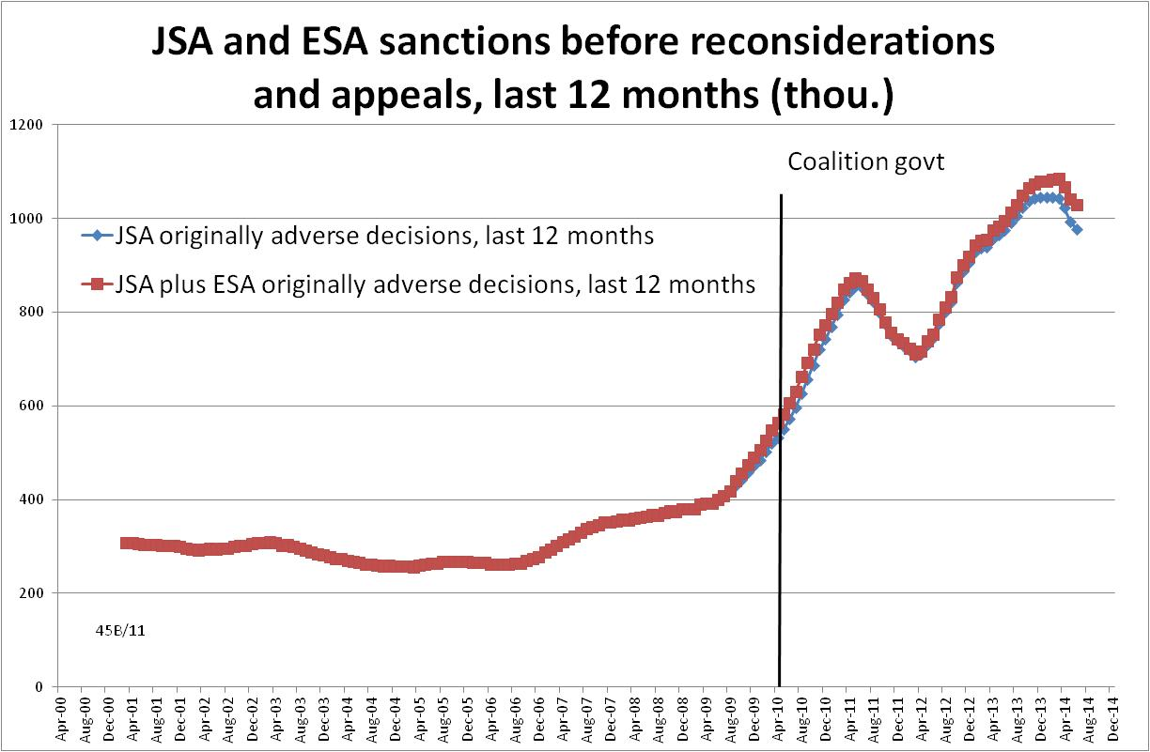

Figure 2
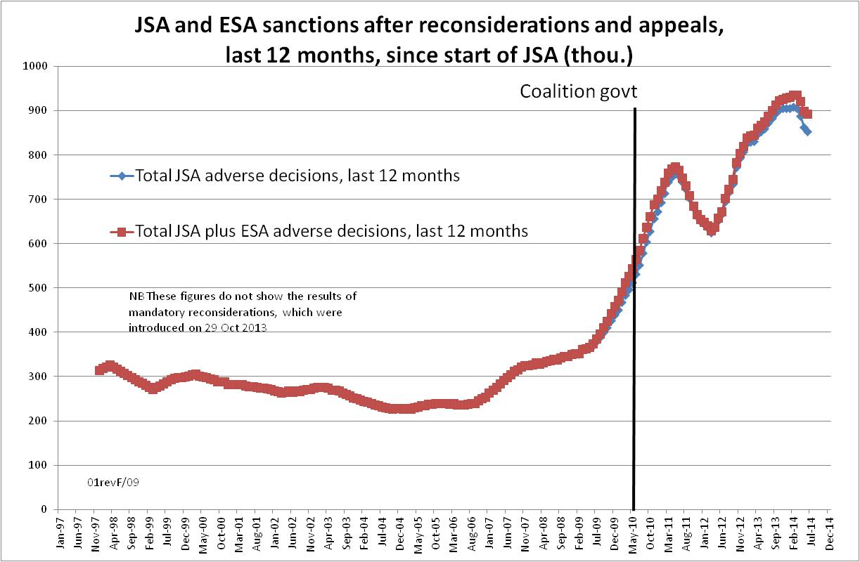

Figure 3
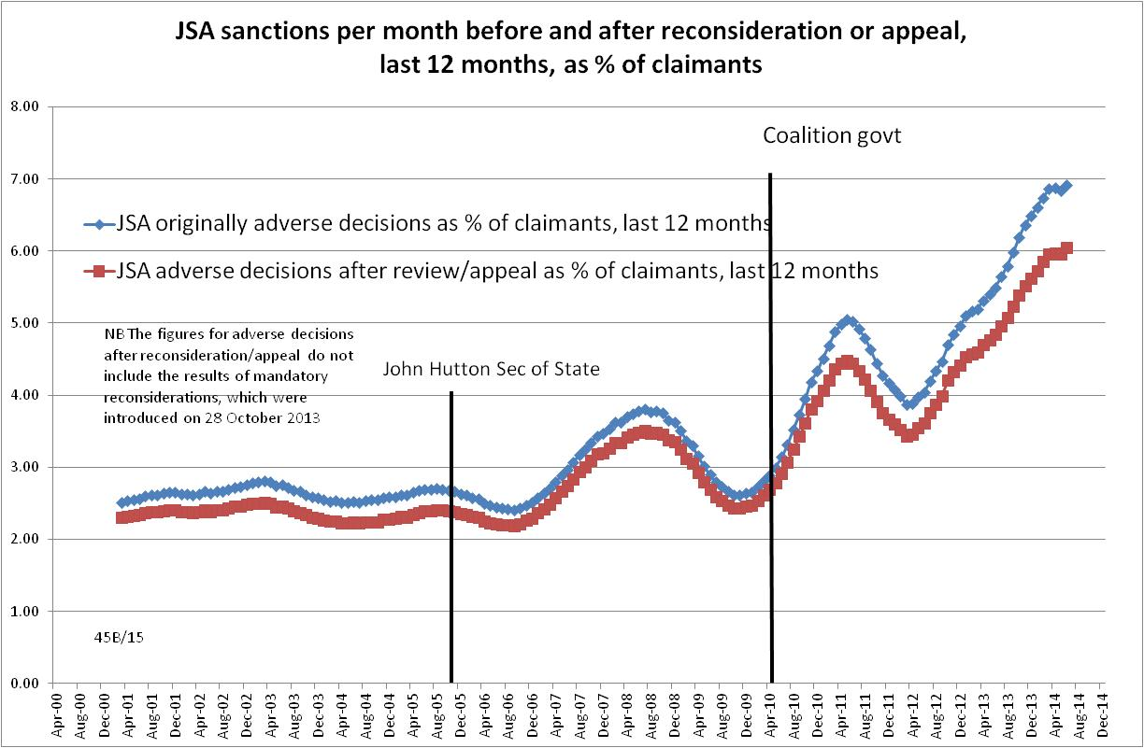
Figure 4
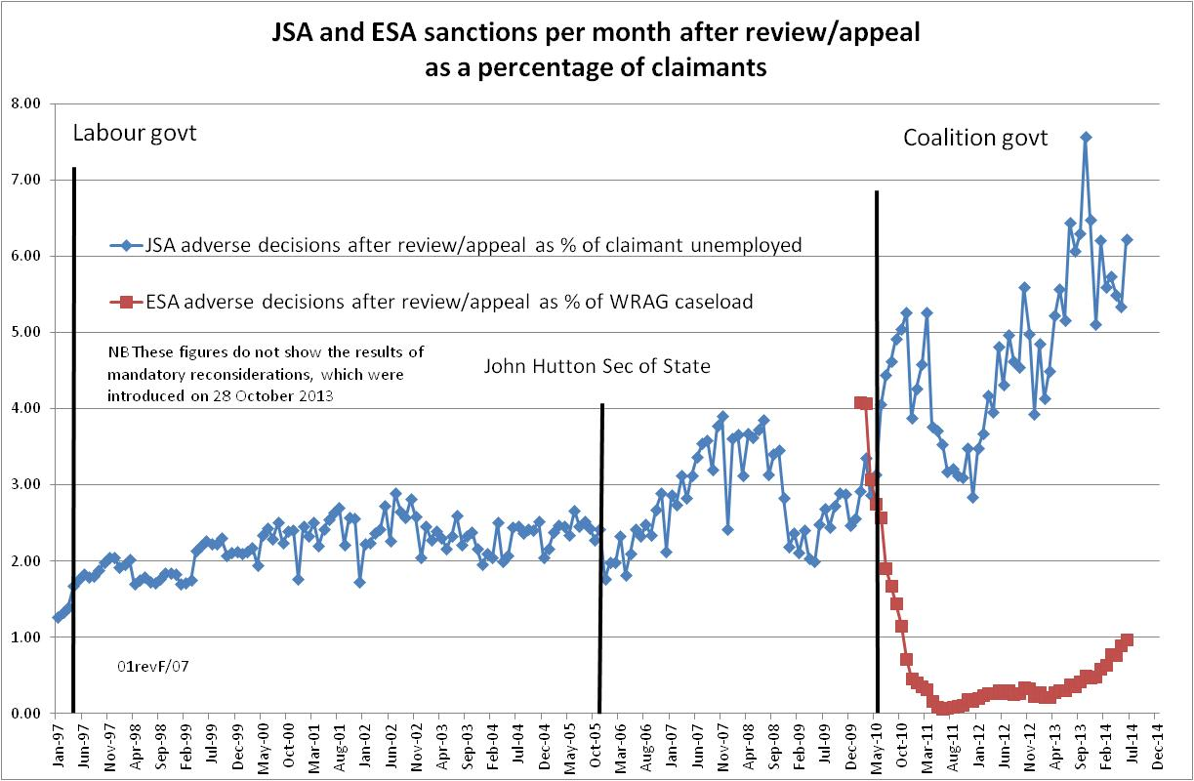

Figure 5
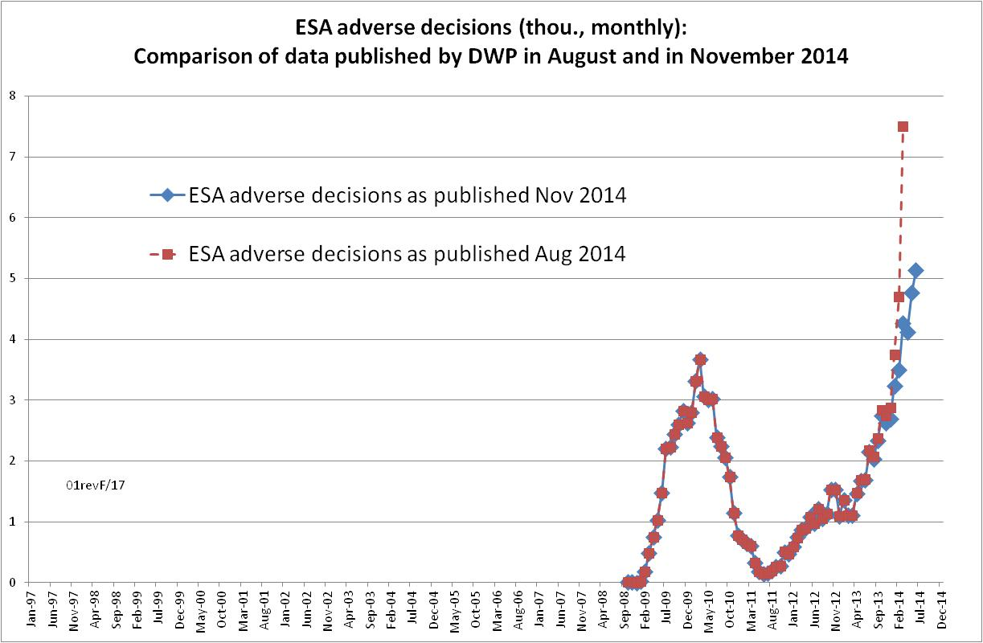

Figure 6
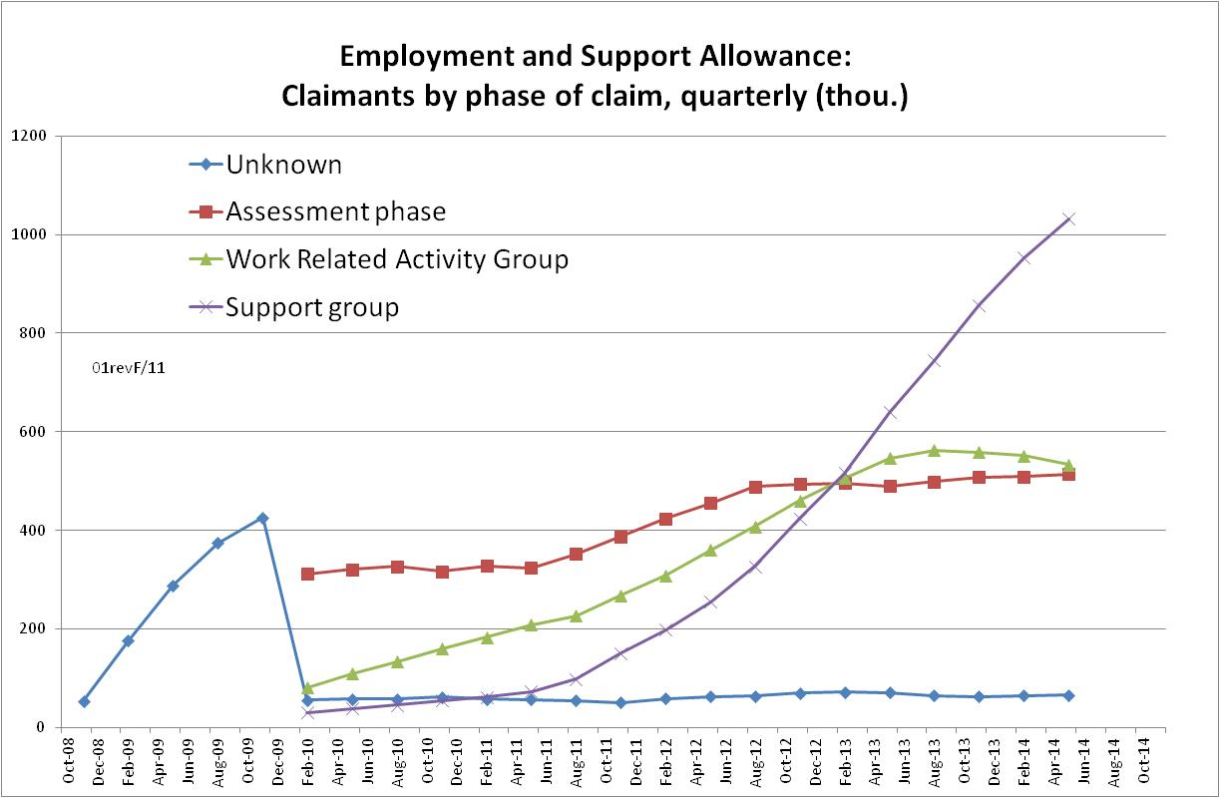

Figure 7
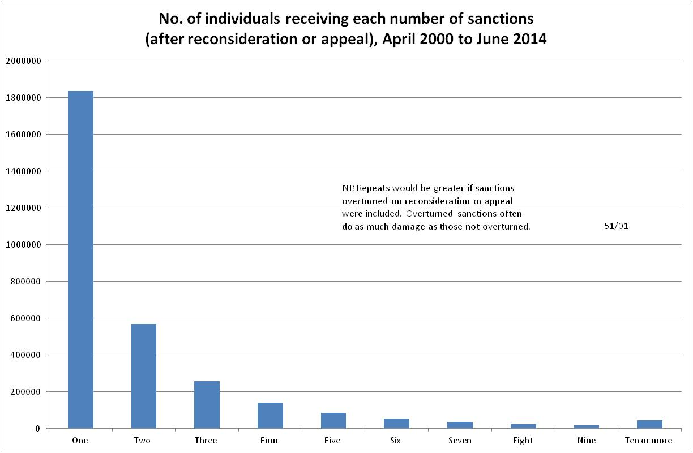

Figure 8
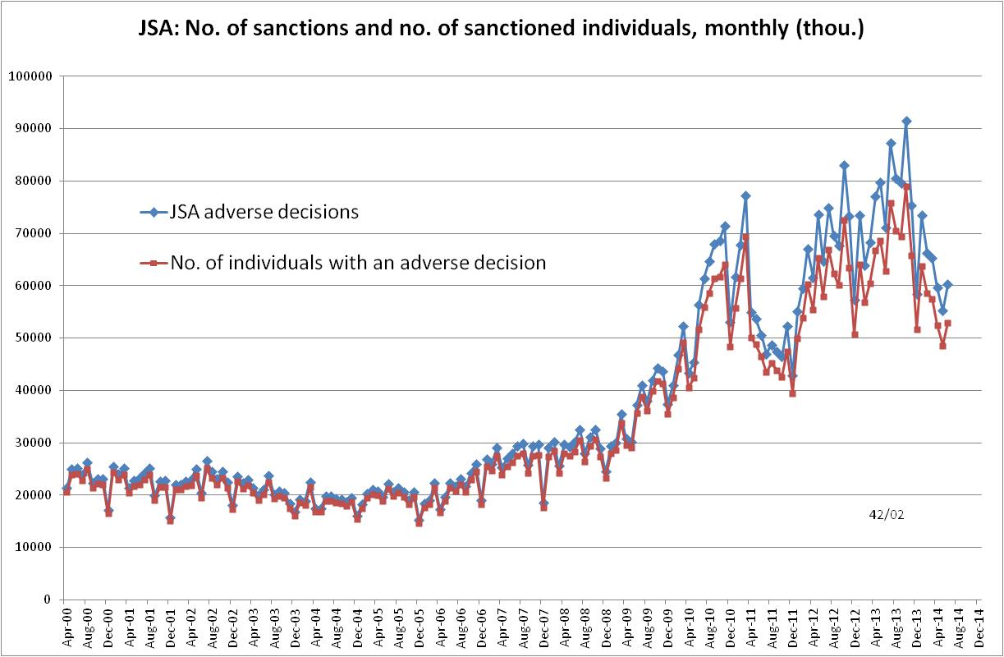
Figure 9
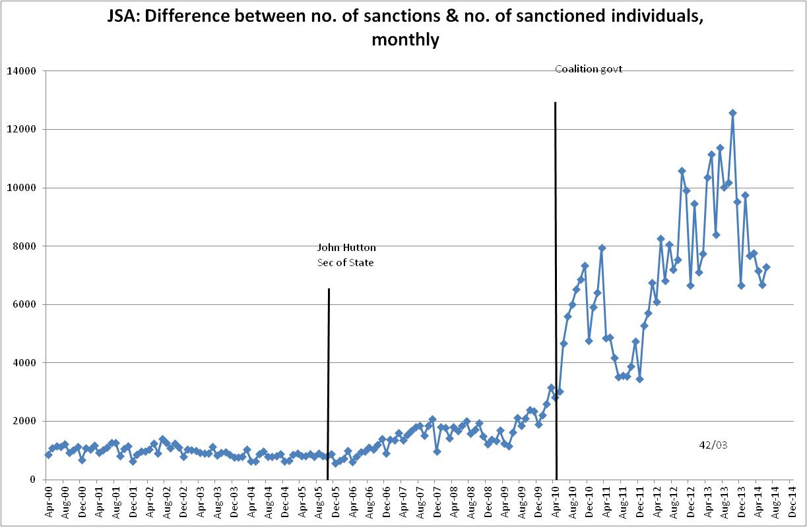

Figure 10
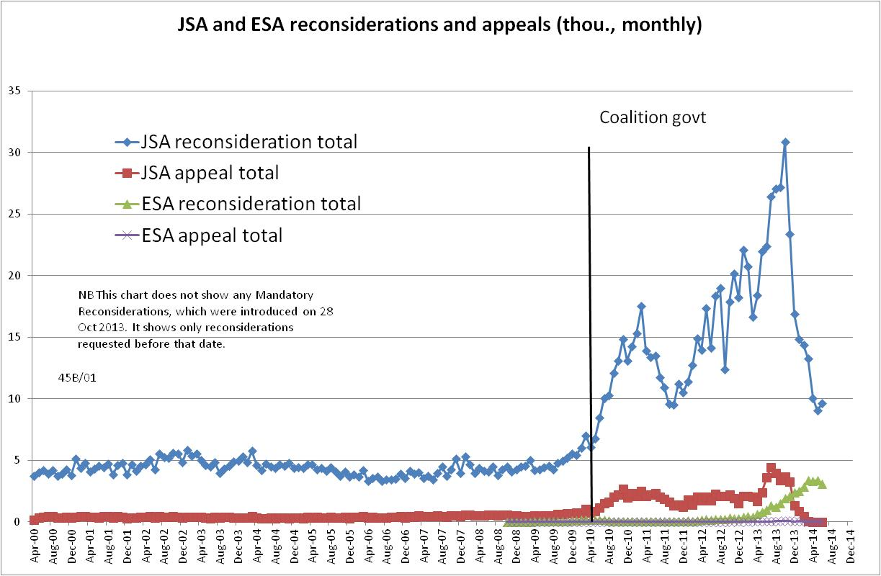
Figure 11
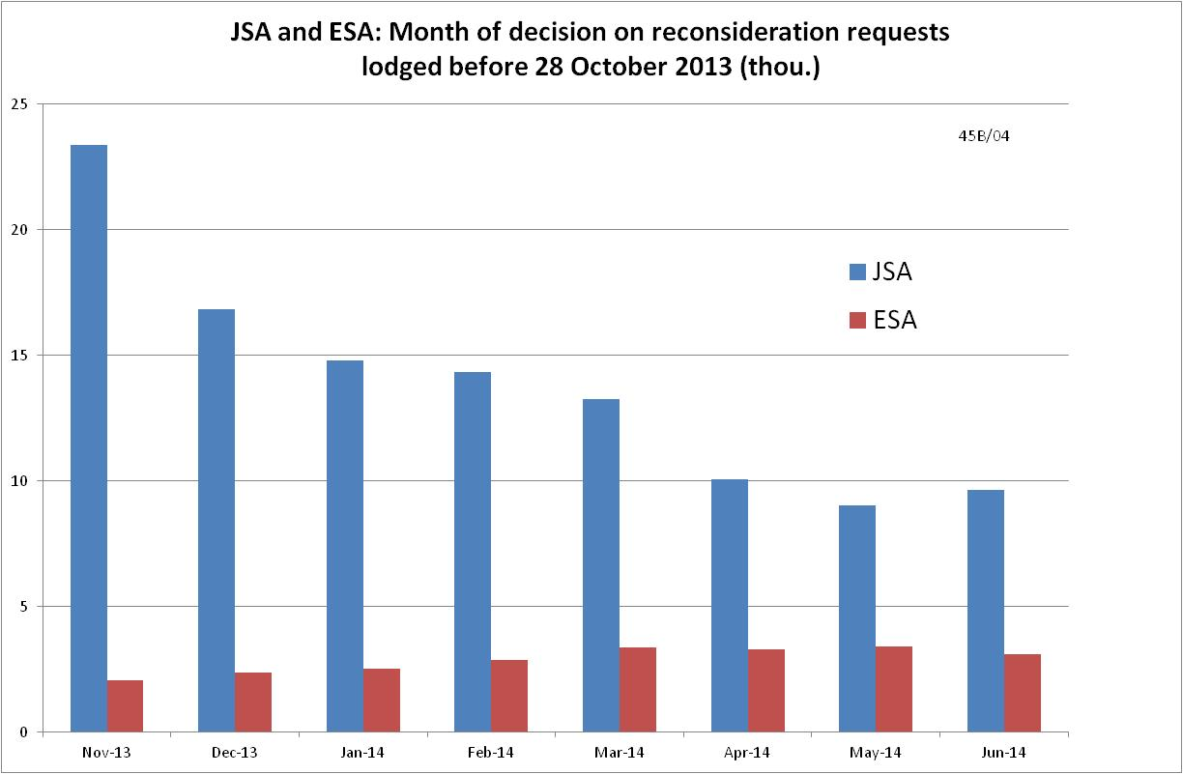

Figure 12
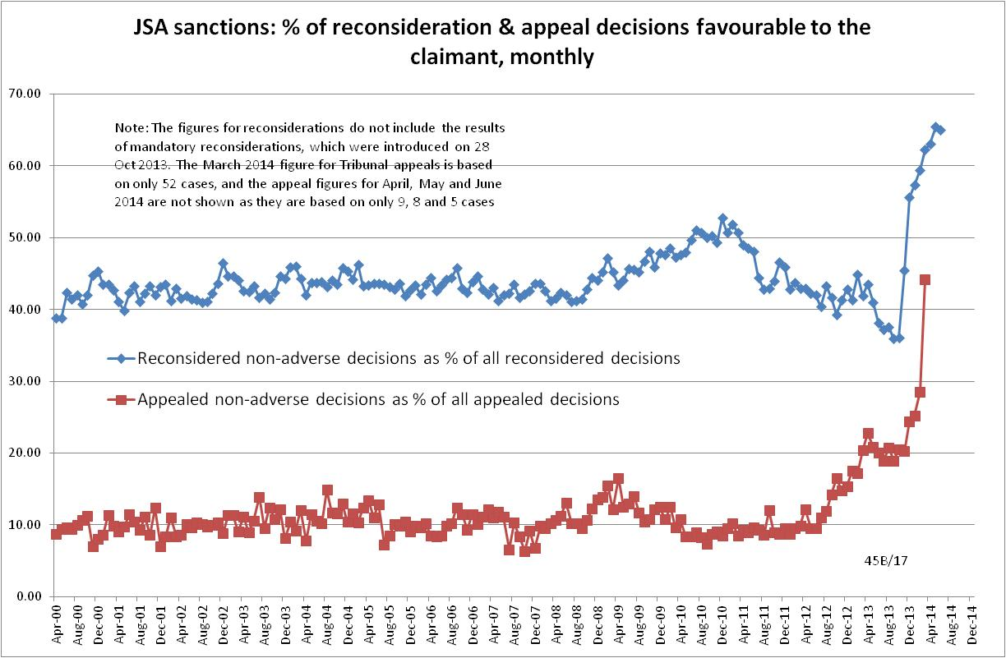
Figure 13
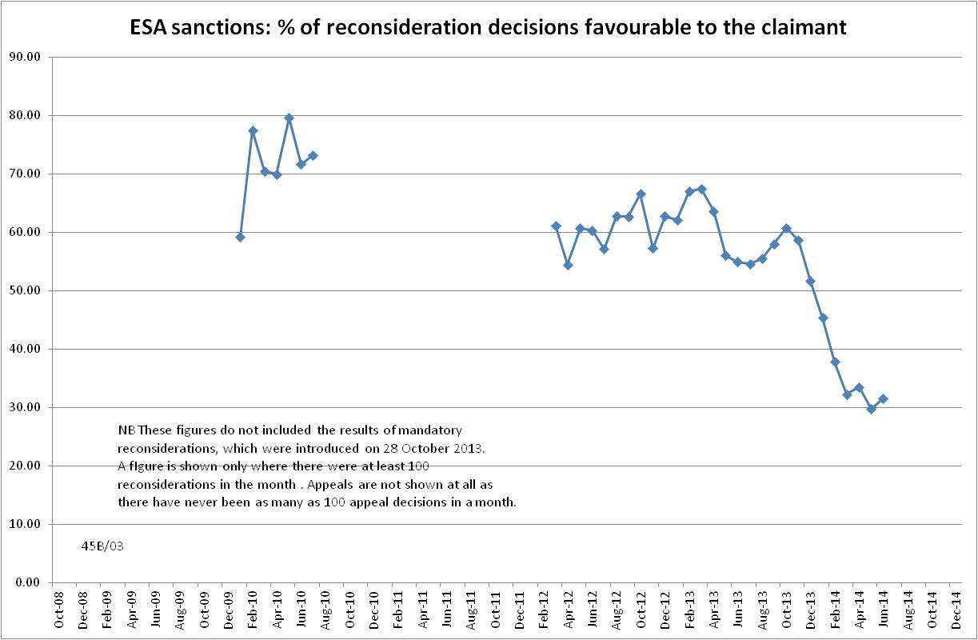

Figure 14
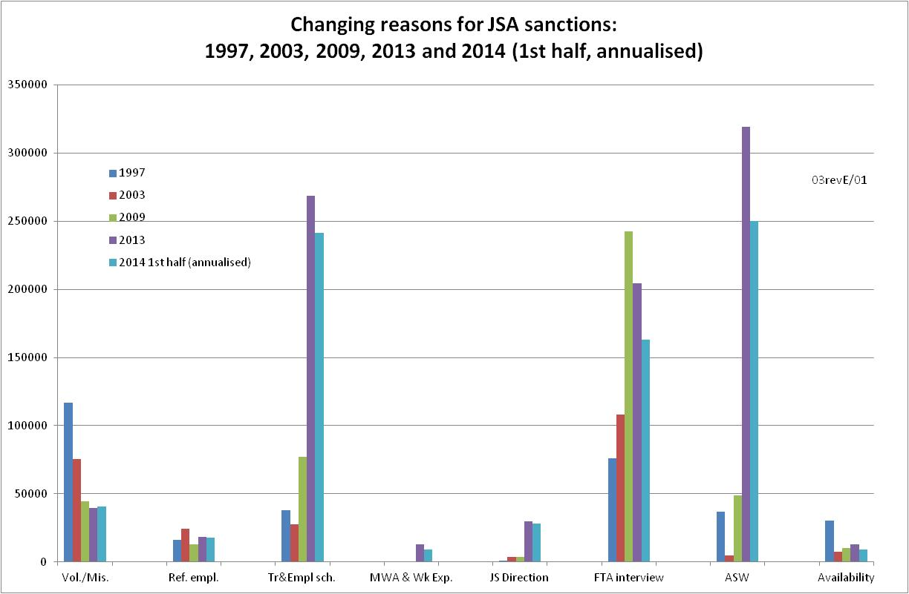

Figure 15
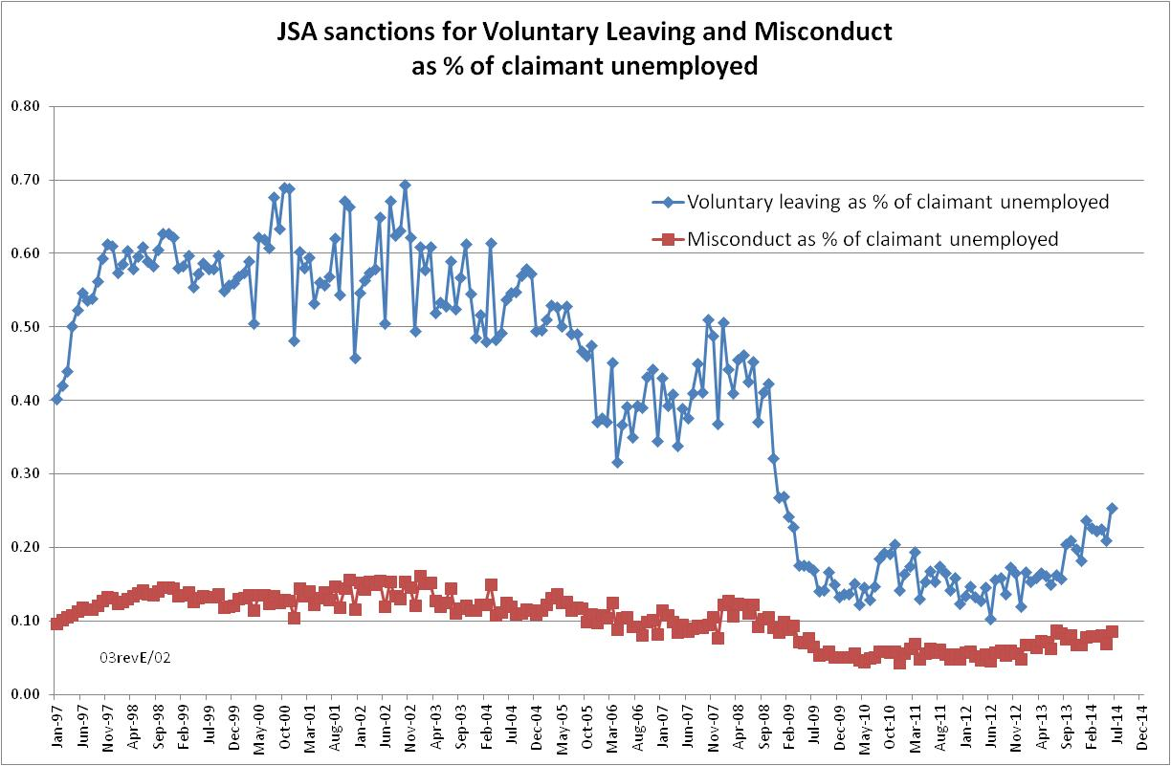

Figure 16
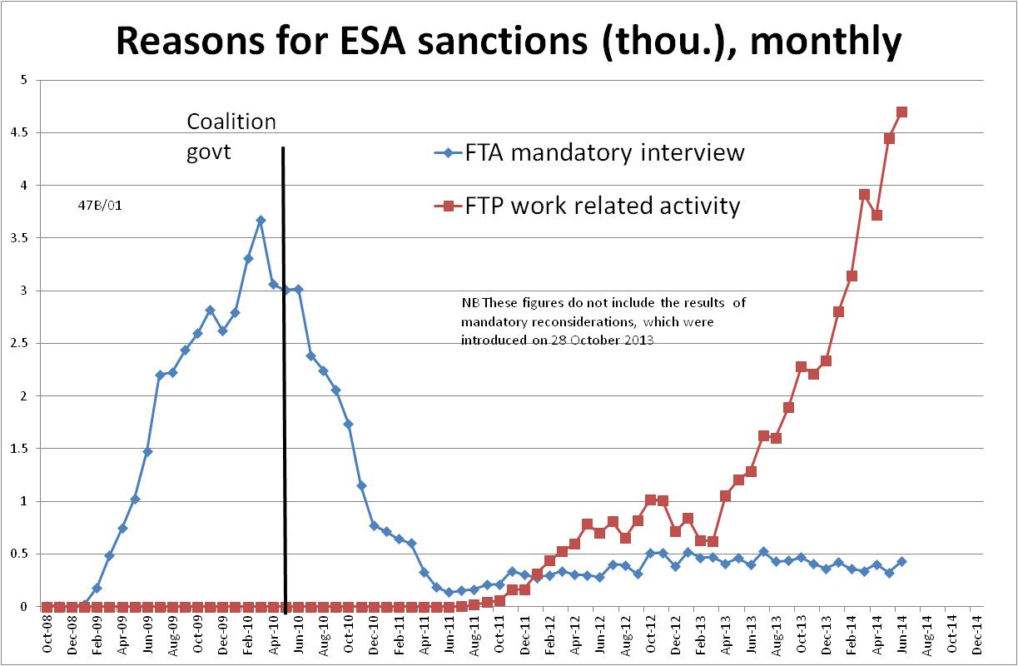

Figure 17
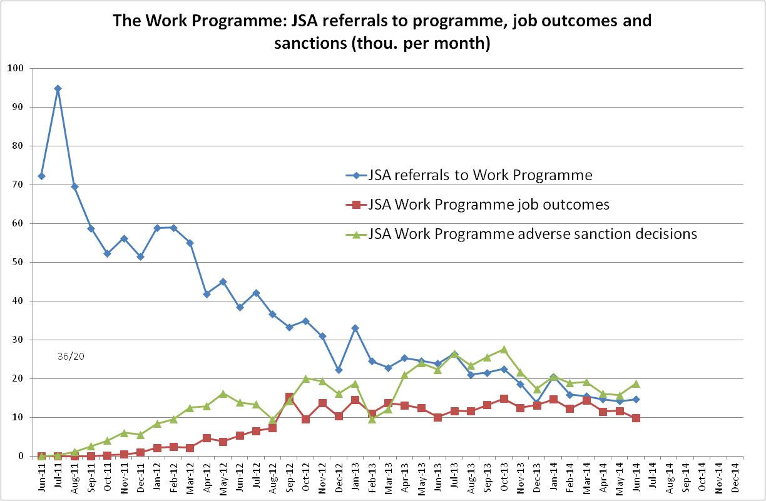

APPENDIX: Methodological issues

The basic concept of the DWP’s statistics on sanction decisions is that each sanction case appears only once in the database, and is given its latest status and attributed to the date of the latest decision on the case. So, for instance, if a decision is made in January 2014 to sanction someone, this decision is reconsidered (‘reviewed’) in March 2014 with an outcome unfavourable to the claimant and is heard on appeal by a Tribunal in September 2014 with a decision favourable to the claimant, then:
- it appears in the statistics for the first time in January 2014 as an adverse decision
- in March 2014 it changes its status to a reconsidered adverse decision and moves month to be with all the other cases where the latest decision has been made in March 2014
- in September 2014 it changes its status again to an appealed non-adverse decision, and moves month again to be with all the other cases where the latest decision has been made in September 2014.

This should be borne in mind when considering any of the figures on sanctions decisions (as opposed to the figures on sanctioned individuals, which raise different issues). It means, for instance, that the sanction decisions which are shown as having appeal decisions favourable to the claimant made in March 2014 were originally made many months earlier, probably at least 6 months. Reconsideration decisions are normally made much closer to the original decision, but will probably usually be made a month or two later. The statistics are not published until a minimum of about 5 months after the original decision, and therefore most reconsidered decisions will already show their final outcome, but many appealed decisions will change their outcome subsequently to first publication. Overall, since only around one third of JSA claimants (40% for ESA) ask for reconsideration and 3 per cent (1 per cent for ESA) appeal to a Tribunal, the effect of these issues is relatively small, but in general it is best to avoid putting too much weight on figures for individual months. The focus should be on trends.

Omission of the results of JSA and ESA mandatory reconsiderations

Since 28 October 2013, sanctioned JSA and ESA claimants have not been allowed to appeal to an independent Tribunal without first making an informal appeal to the DWP itself (a ‘mandatory reconsideration’ or ‘decision review’). Previously they could go directly to a Tribunal if they chose to do so.

The November 2014 DWP Statistical Summary, p.34 explains that ‘mandatory reconsiderations’ are recorded on a separate administrative system, and therefore their results are not being reflected in the main sanctions statistics, although where a case subsequently receives a Tribunal decision, this will be included. What this means is that where sanctions have been overturned on reconsideration, this is not showing up in the sanctions statistics, which continue to show these cases as ‘adverse decisions’. Therefore while the numbers of originally adverse decisions are correctly shown, the number remaining adverse after reconsideration is being overstated.

This effect is not very large. The Statistical Summary estimates it at 2.5%. There is no completely reliable way of correcting for it. However, in this briefing, more prominence is given to the figures for estimated ‘originally adverse decisions’, i.e. the total number of cases where claimants’ money was stopped, whether or not the sanction was eventually overturned on reconsideration or appeal and the money refunded. These figures are not affected by the missing data on reconsiderations. But because of the differences in timing of the different decisions, explained earlier, these figures are not exactly correct for individual months and should only be used to examine trends.

Success rates at reconsideration

In calculating success rates for reconsiderations, the numerator is straightforward. It is the number of reconsiderations with a non-adverse decision shown against the month in question. The denominator has to take into account the fact that all cases that go to Tribunal appeal, if they were previously reconsidered, will have had an adverse decision at reconsideration. Here it is assumed that all appealed cases were previously reconsidered, and therefore the number of appeals decided in the given month is added to the total of reconsiderations for the given month to make the denominator.

Data before April 2000

The DWP Stat-Xplore series runs from April 2000. For key items, this briefing adds in figures back to January 1997 taken from the paper-based former Adjudication Officers’ Decisions series on a comparable basis. Figures can therefore be quoted for the whole of the last Labour government, elected in May 1997, and effectively for the whole of the existence of JSA, which started in October 1996. Data are not quoted for the last quarter of 1996 because for this period there were a substantial number of cases (about 17%) still being processed under the former system.

This is the fifth in a series of briefings on the DWP’s statistics on Jobseeker’s Allowance (JSA) and Employment and Support Allowance (ESA) sanctions. Earlier briefings were produced in August 2014, June 2014 (for the May 2014 release), February 2014 and November 2013. They should be read in the light of the DWP’s statistical revisions, because some of their conclusions are no longer valid. However, much of the data and discussion remains useful, as noted in the present briefing. The earlier briefings are available as follows: August 2014: http://paulspicker.wordpress.com/2014/08/24/david-webster-more-figures-on-sanctions-2/ or http://www.welfareconditionality.ac.uk/2014/08/annual-number-of-jsaesa-sanctions-has-almost-doubled-under-the-coalition-dr-david-webster/ May 2014: http://paulspicker.files.wordpress.com/2014/06/14-05-sanctions-stats-briefing-d-webster-may-2014.pdf or http://www.welfareconditionality.ac.uk/2014/03/the-great-sanctions-debate/#more-179 February 2014: http://paulspicker.files.wordpress.com/2014/02/sanctions-stats-briefing-d-webster-19-feb-2014-1.pdf, http://www.welfareconditionality.ac.uk/share-your-views/ or http://refuted.org.uk/2014/02/22/sanctionsstatistics/ November 2013: http://eprints.gla.ac.uk/90156/
As explained in the Appendix, the numbers of sanctions before reconsideration and appeal cannot be derived with complete accuracy from the information published by the DWP. They have to be estimated.
Published figures for the number of ESA sanctions date from October 2008 whereas those for the size of the Work Related Activity Group date only from February 2010. ESA sanction rates can therefore only be calculated from February 2010. The WRAG caseload for June 2014 has been extrapolated from the figures for Feb and May 2014.
See e.g. House of Commons Work and Pensions Committee (2014) Employment and Support Allowance and Work Capability Assessments, First Report of Session 2014–15, HC 302, 23 July
Peters & Joyce’s figures on repeat sanctions were taken from the DWP’s Sanctions Evaluation Database and referred to all claimants. They were not taken from the sample survey which they were reporting on. Gregg (2008, p.
All other ‘intermediate’ level sanctions also involve closing the claim.
It is also noteworthy that although the present author attended two sanction tribunal hearings in Glasgow in June with decisions favourable to the claimants, the DWP statistics for GB in June show no such decisions at all.
Included here under ‘failure to participate in a training or employment scheme’ are failing to participate in the Work Programme, refusing, neglecting to avail, failing to attend, leaving or losing a place on a training/employment scheme, failing to comply with Skills Conditionality, failing to attend a Back to Work session, and failing to participate in any other training or employment scheme.
http://www.dsdni.gov.uk/minister-speech-nicva-adviceni-october14.htm
Perry et al. (2014) confirms the estimate emerging from previous evidence that sanctions are responsible for about a quarter of food bank use.

