BRIEFING: THE DWP’S JSA/ESA
SANCTIONS STATISTICS RELEASE, 13 August 2014

SUMMARY

The DWP released a further three months’ statistics on sanctions on Wednesday 13 August, covering January-March 2014. It revealed that some 54,000 sanctions since December 2012 for missing an interview had been omitted from the previously published figures but are now included. It also revealed that figures on mandatory reconsiderations have never been included in the sanctions statistics, which therefore have been overstating the number of adverse decisions since 28 October 2013. This omission is taken into account in the conclusions drawn in this briefing.

The new figures show that JSA sanctions have stabilised at the rate of around 7.25% of claimants per month before reconsideration/appeal and 6.25% per month after, which was reached in mid-2013. This is by far the highest rate since JSA was introduced in 1996. ESA sanctions are continuing the rapid increase they began in mid-2013, reaching an estimated 1.58% of claimants per month before reconsideration/appeal, and 1.37% after, in March 2014. In the year to March 2014, an estimated total of 1,104,000 JSA and ESA sanctions were imposed, of which an estimated 149,000 were overturned on reconsideration/appeal, with claimants nevertheless having had payment stopped for weeks or months. The annual number of JSA/ESA sanctions has almost doubled under the Coalition, while the annual number of cases of people losing benefits only to have them reinstated has quadrupled.

Omission of mandatory reconsiderations means that updated success rates for claimants’ first stage appeals cannot be quoted. In addition, introduction of mandatory reconsideration appears to have caused a large fall in cases reaching Tribunals, and updated ESA claimants’ success rates at Tribunals cannot be quoted. However it is clear that JSA claimants’ success rate at Tribunal has doubled under the Coalition, from around 10% to over 20%.

The most common reason for JSA sanctions is ‘not actively seeking work’, which does not mean what it says but that the claimant has not done exactly what they were told by their Jobcentre adviser, often for reasons beyond their control. The second most common reason is non-participation in a training or employment scheme. About 90% of these sanctions relate to the Work Programme, with almost all the rest being Skills Conditionality. ‘Non-participation’ often means simply missing a single interview. Relations between Jobcentre Plus and external contractors were a particular focus of criticism in the Oakley Report (published 22 July), attracting 8 of its 17 recommendations. Missing a JCP advisory interview remains the third most common reason for a sanction, and the corrections in this statistical release show that it has not fallen back nearly as much as previously shown. The big surge in ESA sanctions since mid-2013 has been entirely due to penalties for ‘failure to participate in work related activity’, which now accounts for 96% of ESA sanctions. The Work Programme continues to produce far more sanctions than job outcomes, for both JSA and ESA claimants.

This briefing also has notes on recent other developments in relation to sanctions: changes for homeless claimants and in relation to suspensions of benefit; a recent OECD report on UK activation policy; and the death of a sanctioned claimant, David Clapson, and a subsequent online petition.
BRIEFING: THE DWP’S JSA/ESA
SANCTIONS STATISTICS RELEASE, 13 August 2014

This briefing deals with the statistics on Jobseekers Allowance (JSA) and Employment and Support Allowance (ESA) sanctions released by the DWP on 13 August 2014, which include figures for a further three months, namely January to March 2014. This statistical release includes further revisions to the previously published data for JSA sanctions, back to April 2000. It has also emerged that there is currently a defect in the statistics, in that the results of the ‘mandatory reconsiderations’ for both JSA and ESA sanctions introduced from 28 October 2013 are not included in the database (although the cases to which they relate are included). These data problems raise some complex issues, which are discussed in the Appendix. They are noted in the main text where necessary.

The DWP has published an Excel spreadsheet summary of the statistics at https://www.gov.uk/government/collections/jobseekers-allowance-sanctions and the full dataset is in the Stat-Xplore database at https://stat-xplore.dwp.gov.uk/default.aspx.

The DWP Stat-Xplore series runs from April 2000. For key items, this briefing adds in figures back to January 1997 taken from the paper-based former Adjudication Officers’ Decisions series on a comparable basis. Figures can therefore be quoted for the whole of the last Labour government, elected in May 1997, and effectively for the whole of the existence of JSA, which started in October 1996. The pre-April 2000 data are not affected by any revisions.

All statistics relate to Great Britain. The terms ‘reconsideration’ and ‘review’ are used interchangeably to refer to first-stage appeals internal to the DWP.

Factors influencing the figures

These figures reflect the impact of a continuing fall in the number of JSA claimants, from 1.548m in February 2013 to 1.139m in March 2014. They also reflect a fall in the number of ESA claimants in the Work Related Activity Group, which peaked at 0.563m in August 2014 but fell back to 0.552m in February 2014. The fall in JSA claimants is primarily due to improvement in the labour market, while the fall in the WRAG is due to the reduction in Work Capability Assessments following collapse of the DWP’s contract with Atos.

These figures also reflect the impact of the new ‘Claimant Commitment’ (requiring claimants to spend the equivalent of 35 hours a week looking for work), which was introduced in a rolling programme across Great Britain, running from 14 October 2013 to spring 2014. By 20 December 2013, the Claimant Commitment had been implemented in just over half (366) of all Jobcentres, and by 7 April 2014 in 712 (i.e. in all or almost all Jobcentres). On average therefore, during the January-March quarter the Claimant Commitment was in force in around three-quarters of Jobcentres.

At the end of this briefing there are notes on a few additional recent developments in relation to sanctions.

KEY POINTS FROM THE NEW STATISTICS

As a proportion of those at risk, JSA sanctions have stabilised at a high level while ESA sanctions continue to escalate rapidly

As a proportion of claimants, JSA sanctions appear to have stabilised at the unprecedentedly high levels of over 7% per month before reconsiderations and appeals, and over 6% per month after reconsiderations and appeals, which were reached in mid-2013. ESA sanctions have continued their rapid escalation which started in mid-2013, reaching an estimated 1.58% of claimants before reconsiderations and appeals, and 1.37% after, in March 2014. On an annual basis, the numbers of JSA and ESA sanctions have both risen to new highs. The exact figures for JSA and ESA sanctions will have been affected by the omission of Mandatory Reconsiderations, but the trends reported here are reliable.

- There were an estimated 1,104,000 JSA and ESA sanctions in the year to 31 March 2014, before reconsiderations and appeals (Figure 1). This compares with 564,000 in the last 12 months of the previous Labour government. An estimated 149,000 sanctions were overturned on reconsideration or appeal, but in all cases claimants’ payments will have been stopped for at least 4 weeks. These are the highest figures for any 12-month period since JSA was introduced in 1996. The annual number of sanctions has almost doubled under the Coalition, while the annual number of cases of people losing benefits only to have them reinstated has quadrupled. Multiple case histories show that losing benefits often has catastrophic effects for claimants, even where they are subsequently reinstated. Claimants also frequently have difficulty or delay in actually getting the money back from DWP.

- Total JSA plus ESA sanctions in the year to 31 March 2014, after reconsiderations and appeals, were 954,490. This is the highest for any 12-month period since JSA was introduced in 1996, and about three times the level for any 12-month period before October 2007. (Figure 2)

- The number of JSA sanctions in the year to 31 March 2014, after reconsiderations and appeals, was 918,593, the highest since JSA was introduced in 1996. It compares with 496,771 in the year to 30 April 2010, the last month of the previous Labour government. (Figure 2)

- In the year to 31 March 2014, JSA claimants were sanctioned at the rate of 6.95% per month before reconsiderations and appeals, and 6.05% per month after reconsiderations and appeals. These are the highest rates recorded since the start of JSA in 1996 (Figure 3). The monthly figures suggest that the rate of JSA sanctions has stabilised at the levels of around 7.25% before review/appeal and 6.25% per month after, which was reached in mid-2013 (Figure 4).

- Over the whole period of the Coalition, JSA sanctions have run at 4.65% per month after reconsiderations and appeals. This is almost double the level of approximately 2.42% during the Labour government from May 1997 to April 2010. (Please note that the figure of 4.81% of JSA claimants per month for the Coalition to end-2013 given in the previous briefing should have read 4.54%).

- In the 75 week-period 22 Oct 2012 to 31 Mar 2014, 760,115 individuals received a JSA sanction. Accurate comparison of this figure with earlier periods cannot be made with the data available. The only period for which the DWP statistics permit comparison of numbers of individuals sanctioned is the month. On this basis, the number of individual JSA claimants sanctioned per month (after review/appeal) has fallen back to about 63,000, from the peak of 79,020 (revised upwards from 76,282) which was reached in October 2013.
- There has been a rapid escalation in ESA sanctions since mid-2013. There were 7,507 ESA sanctions in March 2014, after reconsiderations and appeals. This is by far the highest monthly figure since sanctions were introduced for ESA claimants in the Work Related Activity Group in October 2008, and is almost five times higher than the previous peak of 1,527 in October 2012. The figure for the 12 months to 31 March 2014, at 35,892, is also the highest for any 12-month period since ESA sanctions began in October 2008, and compares with 14,072 in the year to March 2013.

- Although the rate of sanctions for ESA WRAG claimants is much lower than for JSA claimants, it continues to rise very fast. From a low of 0.06% per month in June 2011 it has risen to 0.85% in February 2014 and an estimated 1.37% in March 2014 (Figure 4). The DWP has not provided any explanation for the increase in ESA sanctions. It is not due to any increase in referrals to the Work Programme, because these have been falling, from 11,000 per month in December 2012 to under 5,000 now.

JSA claimants given three-year sanctions

- Up to 21 October 2012 the maximum length of a JSA sanction was 6 months. Now claimants can be deprived of benefits for up to 3 years if they ‘commit’ three ‘high level’ ‘failures’ within a year. The new statistics release shows that 1,502 claimants had received three or more ‘high level’ sanctions between the start of the more severe regime on 22 October 2012, and 31 March 2014, a period of just under 18 months. However the number of people receiving three-year sanctions will have been smaller than this because not all of these sanctions will have been within a year (Note: the figure of 1,229 given in the previous briefing for the period to 31 Dec 2013 will have been a slight overestimate for the same reason). The last time that a firm figure for the number of 3-year sanctions was published was for the period from 22 October 2012 to to 30 September 2013, when it was 962.

JSA Reconsiderations and Appeals

The introduction of Mandatory Reconsiderations has had a major effect on the appeal system. Because their results are not being included in the published statistics, reliable figures for reconsiderations cannot be quoted for the most recent few months. In addition, the Mandatory Reconsideration process appears to have caused a large fall in the number of appeals reaching Tribunals. However it is clear that JSA claimants’ Tribunal appeal success rate has doubled under the Coalition.

- Figure 5 shows large falls since October 2013 in both reconsiderations and appeals as a percentage of initially adverse JSA sanction decisions. The fall in reconsiderations is misleading because new requests for reconsideration since 28 October 2013 have not been recorded in the main sanctions database. The fall in Tribunal decisions however is a real fall. It implies that the Mandatory Reconsideration process has caused a big reduction in the flow of appeals reaching Tribunals. This should be reversed as the system settles down, except to the extent that Mandatory Reconsideration, by creating another hurdle, reduces the number of claimants going to Tribunal.

- Figure 6 shows that JSA claimants’ success rates at internal DWP reconsideration/review and at Tribunal have both risen in the latest few months. The reconsideration success rate represents the success rate in earlier non-mandatory reconsideration cases still in the system and may not be representative of all reconsideration cases. The Tribunal success rate is reliable, but relates to a greatly reduced flow of cases, falling to only 20 cases decided in March 2014. However it is clear that claimants’ Tribunal success rate has doubled under the Coalition, from around 10% to over 20%.

ESA Reconsiderations and Appeals

- The problems associated with the omission of mandatory reconsiderations from the sanctions database mean that it is not worth quoting new figures on ESA reconsiderations and appeals. The conclusions for 2013 given in the previous briefing remain approximately correct.

Not ‘actively seeking work’ was the most common reason for JSA sanctions in the year to 31 March 2014, followed by failure to participate in training/employment schemes and missing an interview

Figure 7 compares the number of sanctions in 2013 for each reason with the numbers in 1997, 2003 and 2009 (these are respectively the first full year of JSA, the low point of sanctions under the Labour government, and the last full year of the Labour government).

In the year to 31 March 2014, ‘Not actively seeking work’ was the most common reason for a sanction, followed by failure to participate in a training or employment programme. The prominence of ‘not actively seeking work’ reflects the Coalition government’s emphasis on its ‘claimant commitment’. ‘Not actively seeking work’ does not mean what it says but that the claimant has not done exactly what they were told by their Jobcentre adviser, often for reasons beyond their control. The impact of the massive increase in this type of sanction under the Coalition has been multiplied by the huge increase in the length of penalty. Up to October 2012 the penalty was disentitlement, which lasted only until the claimant recomplied, which could be within a few days. Now there is always a 4-week loss of benefit for a first offence, and 13 weeks for a second. There has also been a huge increase in administration, since each failure now triggers two sets of paperwork, one for the disentitlement and another for the sanction. These are also treated as separate decisions for the purposes of Tribunal appeal, thus multiplying the administrative complexity and the potential for confusion. I have attended five recent ASW sanction Tribunal hearings in Glasgow, of which two were affected by this issue. In one case, the appellant had been sent the papers for the sanction but not those for the disentitlement, which contained all the detailed facts and argument; so the judge had to adjourn the case, creating the expense of a second hearing. In the other, the appellant, presumably out of confusion, had appealed only the disentitlement and not the sanction, so that although they won the case on the substantive issues, they had the choice of either accepting only half their money back, or applying for a late appeal on the sanction, which would generate further paperwork and expense.

The Work Programme now accounts for about 90% of sanctions for ‘failure to participate in a training or employment programme’, with almost all the rest being Skills Conditionality, a programme which is also contracted out to external providers. ‘Failure to participate’ also often does not mean what it says, but can relate simply to missing a single interview even when there has otherwise been a pattern of full participation. Weaknesses in liaison between Jobcentre Plus and external contractors were particularly criticised in the Oakley Report, attracting 8 of its 17 recommendations. The contractors are not involved in drawing up the Claimant Commitment and do not know what is in it; there is no liaison over potentially conflicting requirements being placed on claimants by the two agencies; contractors have no discretion to consider whether the claimant had a good reason for not complying with a requirement before referring them for sanction; and the Jobcentre Plus adviser is not told when a claimant is referred for sanction by a contractor. In the light of this, it is not surprising to see reports of very large numbers of wrongful sanctions of this type.

Previous statistical releases by the DWP have been misleading in that since December 2012, some decisions for failing to attend a JCP adviser interview have been made by Independent Decision Makers at a local office, and these decisions were not being recorded in the official statistics on JSA sanctions. Some 54,000 sanctions of this type were omitted from the figures previously published for 2013. When these are added in, missing an advisory interview remains the third most common reason for a sanction, but is seen not to have fallen back nearly as much as was previously shown. Figure 8 shows that these sanctions are now running at about 1.25% of claimants per month, which is a lower rate than was inherited from the previous Labour government. However, these sanctions are now for 4 weeks, compared to 1 or 2 weeks from April 2010 to October 2012. Before April 2010, the penalty was ‘disentitlement’, meaning that the claimant’s existing claim was discontinued but they could start another after a small number of waiting days. Like the other two main reasons for sanction, ‘failure to attend’ frequently does not mean what it says, but simply that the claimant was a little late.

This briefing does not update the charts for the other individual reasons for sanction as there is not a great deal of change in the latest figures, and they may be affected by the omission of mandatory reconsiderations.

Reasons for ESA sanctions

- The big surge in ESA sanctions since mid-2013 has been entirely due to penalties for failure to participate in work related activity (Figure 9). By March 2014 this reason accounted for 96% of ESA sanctions, the other 4% being for failure to attend a work related interview. This is in contrast to the experience under the Labour government, when the only reason for sanction was failure to attend an interview. From these figures it looks as though the big spike in ESA sanctions from their start in 2008 up to summer 2011 may well have been due to an initial lack of awareness among claimants that attendance at these interviews had become compulsory. By contrast, the current spike under the Coalition is clearly due to aggressive pursuit of ‘activation’.

The Work Programme: Still far more sanctions than job outcomes

- The Work Programme continues to deliver far more JSA sanctions than JSA job outcomes. Up to 31 March 2014 there had been 280,140 JSA Work Programme job outcomes and 503,220 JSA Work Programme sanctions (Figure 10).
- A similar comparison cannot be made accurately for ESA Claimants, because although the majority of sanction cases under "failure to participate in work related activity" will have been referred from the Work Programme, not all will have been. However, up to 31 March 2014 there had been 14,110 ESA Work Programme job outcomes and 41,721 ESA Work Related Activity sanctions. It is therefore clear that within the Work Programme, ESA sanctions greatly exceed ESA job outcomes.

SANCTIONS - OTHER DEVELOPMENTS

CHANGES TO THE SANCTIONS REGIME

Suspensions

In its response to the Oakley Report on 22 July (p.8), the government stated that it has ‘started development of a new process where advisers identify doubt about whether a claimant has been actively seeking work. This will change the longstanding system where benefit payment is suspended without a decision from a decision maker. Instead we will ensure that a decision is made before benefit payment is stopped. We expect this to take effect from July 2014.’ This is an important reform, because there are many cases where claimants’ benefits are stopped, and they are unable to appeal, for substantial periods while the DWP takes its time to make a decision.

However, the government statement implies that this reform will apply only to issues of actively seeking work. Although this is by far the most frequently occurring reason for suspension, it is not the only one. The others are where doubts are identified on a claimant’s entitlement to JSA because of availability, limited capability for work, refusal to sign a Jobseeker’s Agreement or compensation payments, which include final earnings from their employer; or further information or evidence is needed which may affect the award, or
there is an indication that the amount of JSA may be reduced.

Homeless claimants

The government has made a concession in relation to homeless people in the Jobseeker’s Allowance (Homeless Claimants) Amendment Regulations 2014 No. 1623 which came into effect on 21 July. The DWP’s guidance in Memo DMG 16/14 is available at https://www.gov.uk/government/uploads/system/uploads/attachment_data/file/327633/m-16-14.pdf

Under the new rules, Jobcentre Plus advisors will be given discretion to exempt homeless people from being available and looking for work if they consider that their situation constitutes a ‘domestic emergency’ as mentioned in the existing Decision Makers Guide, para. 21337. ‘Domestic emergency’ has no definition but it appears that it will be defined narrowly as the Memo gives as an example of someone who would not qualify ‘Chester’, who ‘has no fixed address but moves around staying with friends, family and sometimes sleeps rough. Chester has been living like this for the past three months’. Claimants will also have to prove they are taking reasonable action to find accommodation.

OAKLEY REPORT

The report into the working of some sanctions by Matthew Oakley, appointed as independent reviewer under the Jobseekers (Back to Work Schemes) Act 2013, was published on 22 July, the last day of sitting of the House of Commons before the summer recess. In spite of its narrow terms of reference, it makes valuable points.

Some 34 of the 89 organizational responses listed in the Oakley report are available on the Child Poverty Action Group website at
http://www.cpag.org.uk/content/oakley-sanctions-review-responses-other-organisations

While the government has claimed that it has accepted all of Oakley’s 17 recommendations, in fact, in relation to 11 of them it has either refused to implement them, or has not given a firm commitment to implementation, or is not proposing to adopt an effective solution, or has given no timescale.

OECD REPORT ‘CONNECTING PEOPLE WITH JOBS’

On 15 July the OECD published a report Connecting People with Jobs: Activation Policies in the United Kingdom, at http://www.oecd.org/employment/emp/activelabourmarketpoliciesandactivationstrategies.htm

This is the first of a planned series of reports examining active labour market policies in the various OECD countries. The OECD has a record of promoting belief in supply-side theories of the labour market and is also a cheerleader for benefit sanctions. However, this new report is quite useful. It compares UK policies with what the OECD considers to be best practice, and makes a number of serious criticisms. Among the points it makes are:
- little is known about the 3/4 million unemployed people not claiming JSA and they should be researched
- Jobcentre Plus does not measure whether people leaving JSA actually enter employment (this is a criticism already made by the House of Commons Committee of Public Accounts in its report Department for Work and Pensions: Responding to change in jobcentres, Fifth Report of Session 2013–14, HC 136 19 June 2013)
- to date no benefits have emerged from the conditionality regime for people claiming Employment and Support Allowance
- JCP should develop effective profiling procedures for new claimants to assess their needs for support (this is a recommendation already made by the House of Commons Work and Pensions Committee)
- JCP should assess whether the new requirements placed on claimants of unemployment benefits genuinely increase the volume and quality of job search
- JCP should be given an additional remit to assist parents in the search for childcare to enable parents to move into better quality jobs
- expenditure for labour market training programmes in the United Kingdom is among the lowest in the OECD
- little attention has been paid to the fact that claimants forced to use Universal Jobmatch, threatened with sanctions, might start sending applications also for unsuitable jobs where they lack qualifications and skills (there is already a lot of evidence that this happens)
- there should be further research into the working and effects of the UK sanctions regime.

DEATH OF DAVID CLAPSON AND PETITION FOR A FULL INDEPENDENT INQUIRY INTO THE SANCTIONS REGIME

It was always likely that the Coalition’s intensification of JSA and ESA sanctions would lead to fatalities. The Guardian on 3 August 2014 reported the case of a diabetic JSA claimant in Stevenage, David Clapson, whose death in July 2013 appears definitely to have been due to a benefit sanction, in this case a 4-week sanction for missing two Work Programme interviews. Full details are at
http://www.theguardian.com/society/2014/aug/03/victims-britains-harsh-welfare-sanctions

Subsequently, Mr Clapson’s sister has launched an online petition calling for a full independent inquiry into the sanctions regime, at https://www.change.org/en-GB/petitions/david-cameron-hold-an-inquiry-into-benefit-sanctions-that-killed-my-brother
To date it has attracted 86,293 signatures.

24 August 2014

Dr David Webster
Honorary Senior Research Fellow
Urban Studies
University of Glasgow

Email david.webster@glasgow.ac.uk
Webpage: http://www.gla.ac.uk/schools/socialpolitical/staff/davidwebster/

Figure 1
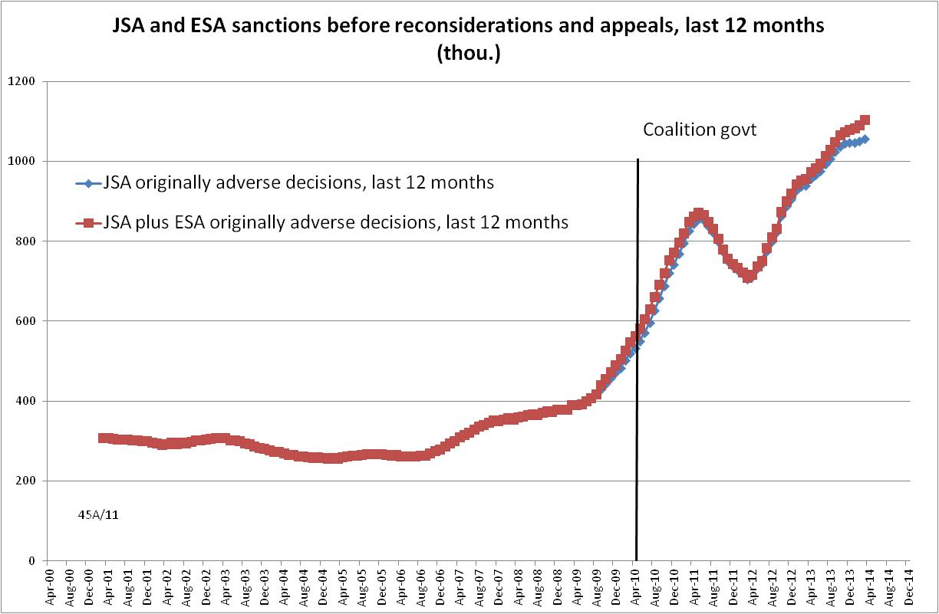

Figure 2
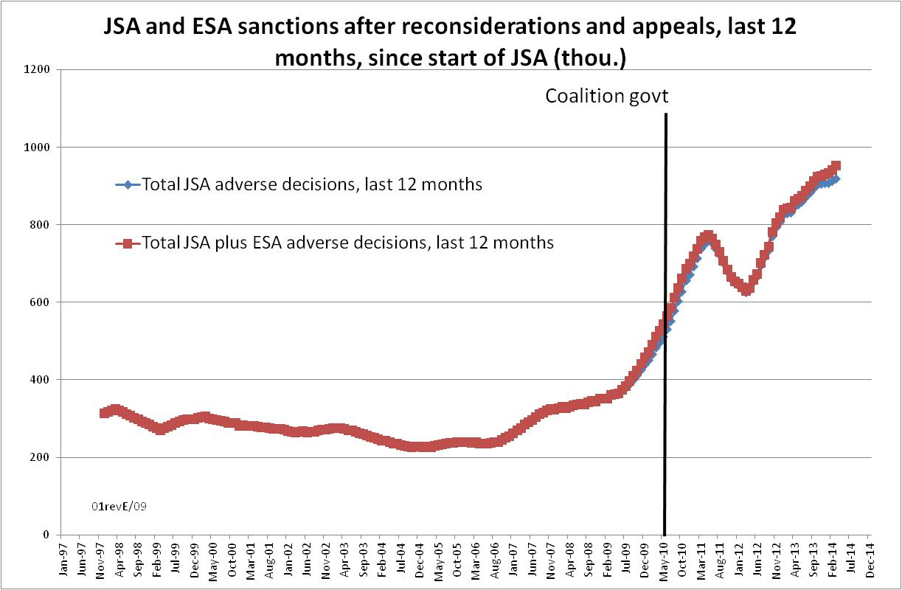

Figure 3
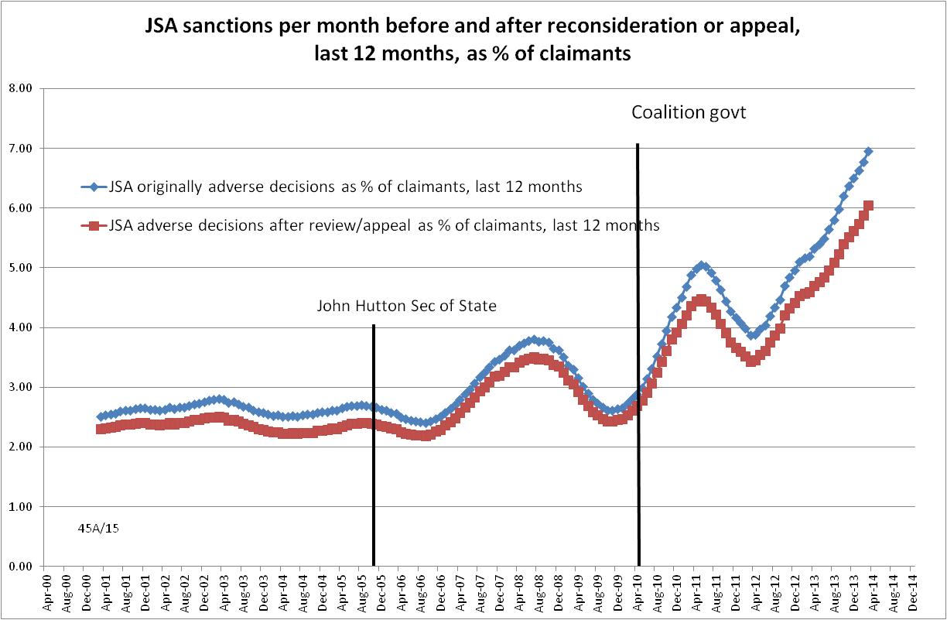
Figure 4
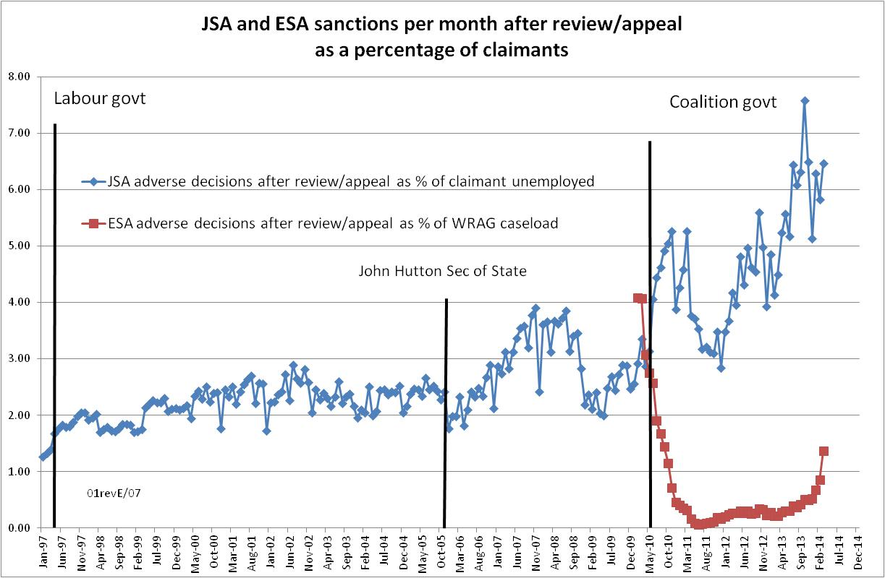

Figure 5
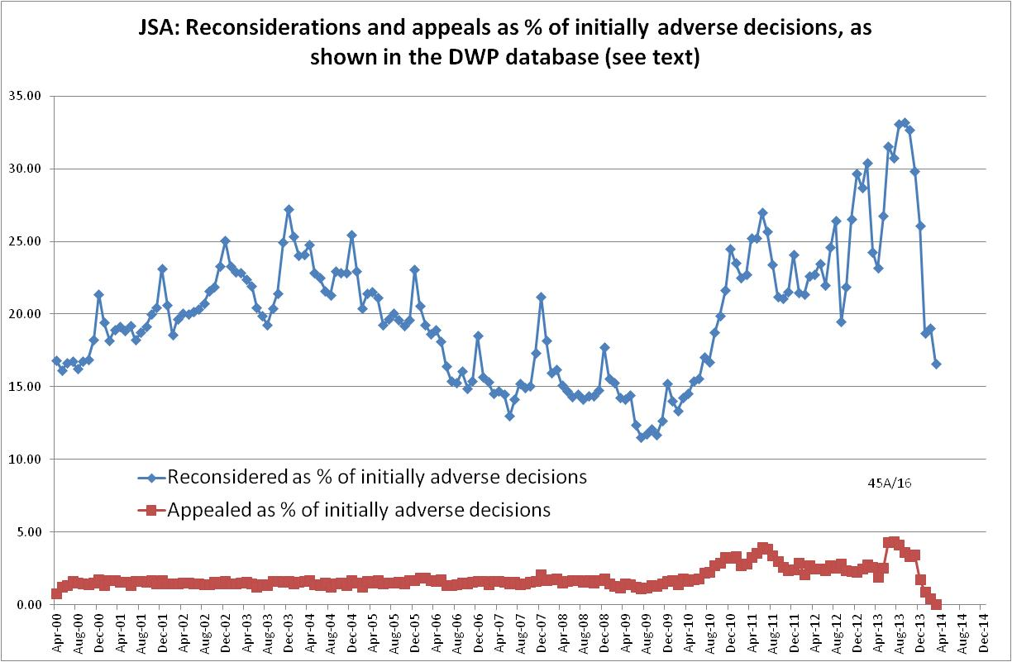

Figure 6
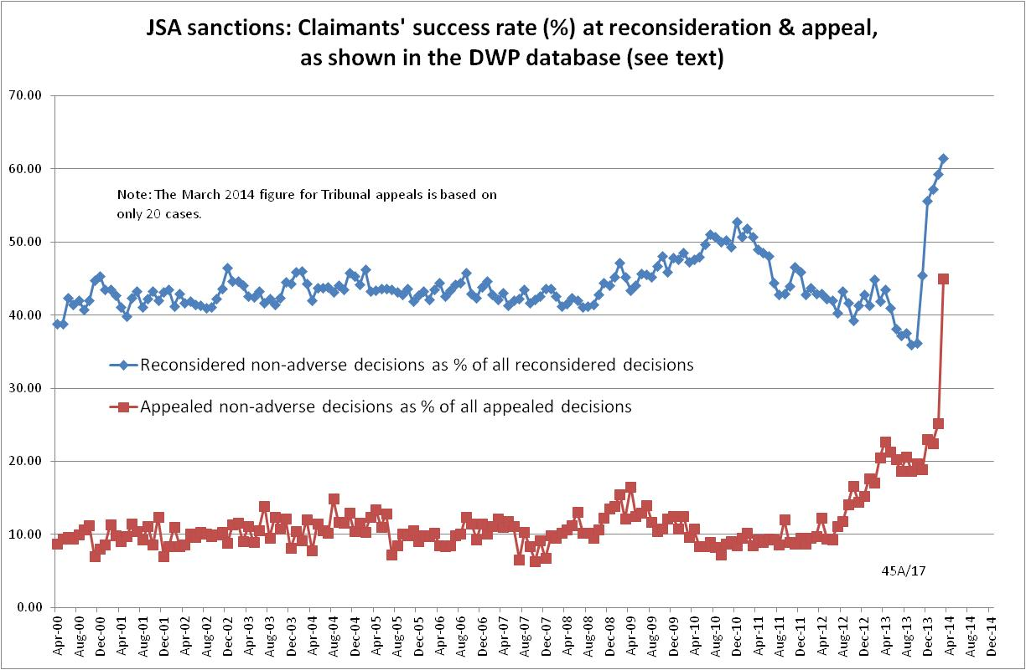

Figure 7
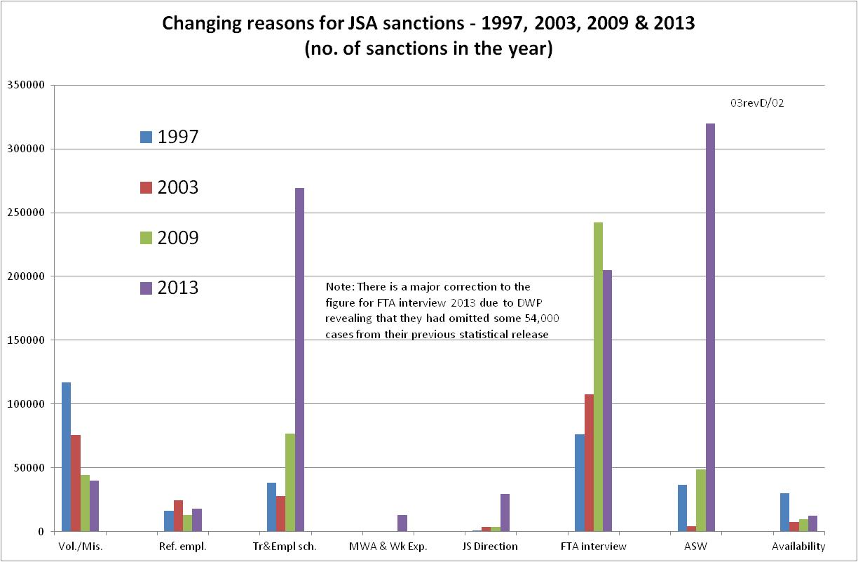
Figure 8
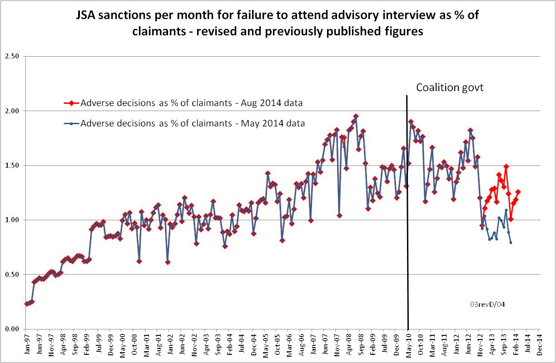
Figure 9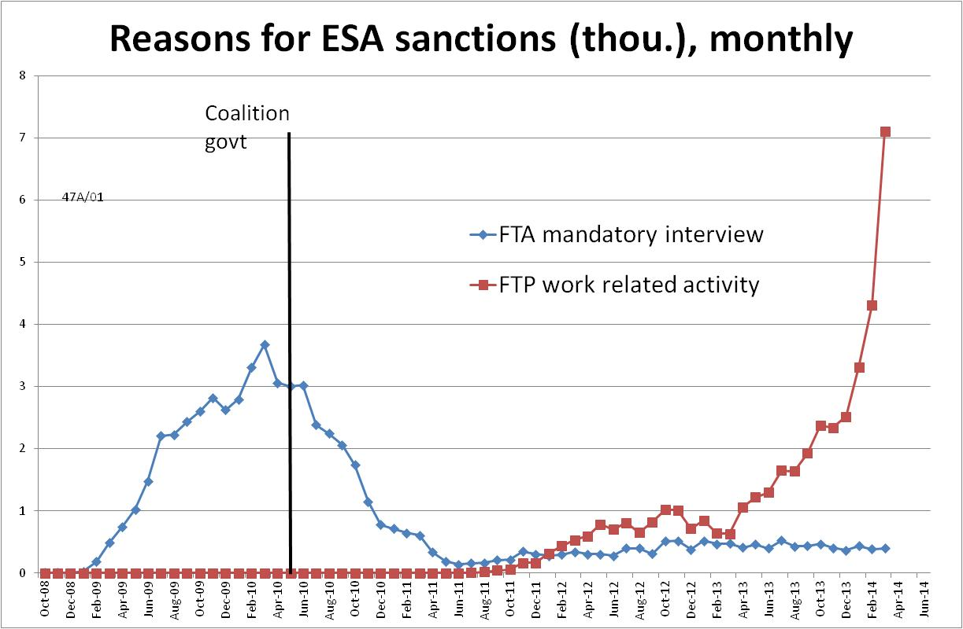

Figure 10
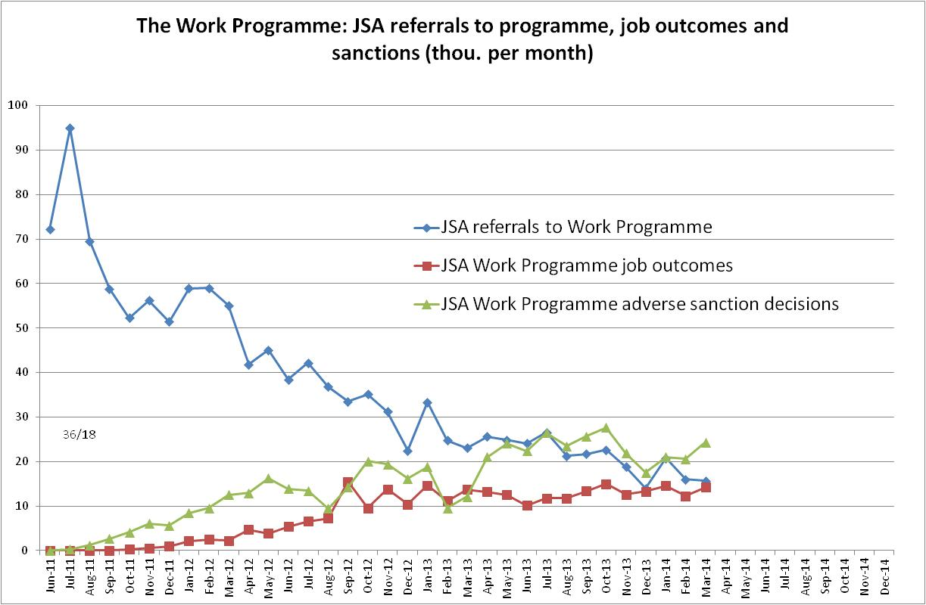

APPENDIX: Methodological issues

This appendix deals with methodological problems relating to the DWP’s statistics on sanctions decisions. The data on sanctioned individuals involve different issues.

The basic concept of the DWP’s statistics on sanction decisions is that each sanction case appears only once in the database, and is given its latest status and attributed to the date of the latest decision on the case. So, for instance, if a decision is made in January 2014 to sanction someone, this decision is reconsidered (‘reviewed’) in March 2014 with an outcome unfavourable to the claimant and is heard on appeal by a Tribunal in September 2014 with a decision favourable to the claimant, then:
- it appears in the statistics for the first time in January 2014 as an adverse decision
- in March 2014 it changes its status to a reconsidered adverse decision and moves month to be with all the other cases where the latest decision has been made in March 2014
- in September 2014 it changes its status again to an appealed non-adverse decision, and moves month again to be with all the other cases where the latest decision has been made in September 2014.

This should be borne in mind when considering any of the figures on sanctions decisions (as opposed to the figures on sanctioned individuals, which raise different issues). It means, for instance, that the sanction decisions which are shown as having appeal decisions favourable to the claimant made in March 2014 were originally made many months earlier, probably at least 6 months. Reconsideration decisions are normally made much closer to the original decision, but will probably usually be made a month or two later. The statistics are not published until a minimum of about 5 months after the original decision, and therefore most reconsidered decisions will already show their final outcome, but many appealed decisions will change their outcome subsequently to first publication. Overall, since only around one third of JSA claimants (40% for ESA) ask for reconsideration and 3 per cent (1 per cent for ESA) appeal to a Tribunal, the effect of these issues is relatively small, but in general it is best to avoid putting too much weight on figures for individual months. The focus should be on trends.

Major revisions to the JSA sanctions data and their impact

The August 2014 DWP Statistical Summary informs us for the first time that since December 2012, some decisions for failing to attend a JSA adviser interview have been made by Independent Decision Makers at a local office, and that these decisions were not being recorded on the Decision Making and Appeal System (DMAS), which is the data source for the official statistics on JSA and ESA sanction decisions. Therefore, data on these JSA decisions have not been incorporated into the official statistics within previous releases for December 2012 and after, which have therefore understated the numbers of JSA sanctions. The official statistics released on 13 August 2014 do now incorporate these additional data. According to DWP, the effect on previously published official statistics is that:
- just under 1 per cent additional decisions to apply a JSA sanction for the whole period between April 2000 and December 2013 are included.
- for the period between December 2012 and December 2013, just over 6 per cent additional decisions to apply a JSA sanction are included.

In May 2014 the DWP revealed that the statistics published previous to that date had overstated the numbers of sanctions because a substantial number of cases, back to April 2000 but particularly in recent months, had been double-counted. The latest corrections therefore to some extent cancel out the effect of the May 2014 corrections. Figure A.1 shows the total number of JSA sanctions (after reconsiderations and appeals) as published in the statistics releases of February, May and August 2014. It will be seen that although the figures move about, the changes are not large in proportional terms and trends are largely unaffected.

However, it is obvious that the effect on the previously published numbers of sanctions for the specific reason of not attending an advisory interview is much greater, as is explained in the main text.

Omission of the results of JSA and ESA mandatory reconsiderations

Since 28 October 2013, sanctioned JSA and ESA claimants have not been allowed to appeal to an independent Tribunal without first making an informal appeal to the DWP itself (a ‘mandatory reconsideration’ or ‘decision review’). Previously they could go directly to a Tribunal if they chose to do so.

The August 2014 DWP Statistical Summary explains that ‘mandatory reconsiderations’ are recorded on a separate administrative system, and therefore their results are not being reflected in the main sanctions statistics, although where a case subsequently receives a Tribunal decision, this will be included. What this means is that where sanctions have been overturned on reconsideration, this is not showing up in the sanctions statistics, which continue to show these cases as ‘adverse decisions’. Therefore while the numbers of originally adverse decisions are correctly shown, the number remaining adverse after reconsideration is being overstated.

This effect is not very large. As a percentage of initially adverse decisions, JSA reconsiderations have been rising but have remained less than 30%, and of these reconsiderations only about 40% result in the sanction being overturned. Moreover, the statistics for latest three months still show the results of reconsideration of around 17% of adverse decisions. Therefore adverse decisions are being overstated only by about 5%. Similar considerations apply to ESA sanctions.

There is no completely reliable way of correcting for this overstatement of adverse decisions. However, in this briefing, more prominence is given to the figures for estimated ‘originally adverse decisions’, i.e. the total number of cases where claimants’ money was stopped, whether or not the sanction was eventually overturned on reconsideration or appeal and the money refunded. These figures are not affected by the missing data on reconsiderations. But because of the differences in timing of the different decisions, explained earlier, these figures are not exactly correct for individual months and should only be used to examine trends.

Proportion of decisions appealed and success rates at Appeal

Only an approximate figure can be obtained for the proportion of adverse sanctions which are appealed to a Tribunal in any individual month. This is because of the time lags between initial decision, reconsideration and appeal. The time between original decision and reconsidered decision is generally short enough that by the time the statistics are published (at least 5 months and up to 8 months after the original decision), almost all of the cases that are going to be reconsidered will have been. But the lag between reconsideration and Tribunal decision can be much longer and appealed cases will still be changing their status after the statistics are published.

In calculating the proportion of sanctions which are appealed, the number of appeal decisions in a given month has to be measured against the total of reconsidered and appealed decisions made in that month, plus original adverse decisions made in the month; but the different cases may have widely different months of original decision, and therefore the denominator may be too high or too low. Figures for individual months should therefore be treated with caution. The focus should be on longer term trends.

However, success rates for appeals are straightforwardly available because the number of successful appeals in a given month is measured against the total number of appeal decisions in that month.

Proportion of decisions reconsidered and success rates at reconsideration

Calculations for reconsiderations are more complicated than those for appeals.

Only an approximate figure can be obtained for the proportion of sanction decisions reconsidered in any given month. The numerator has to add together the number of reconsidered decisions shown against that month, together with the number of appeals decided in that month which were previously given an adverse decision at reconsideration. This creates two problems, namely that the appealed decisions probably had their reconsideration decisions in a previous month (this is the same time-lag problem as for appeals discussed above); and that while all appealed cases with an original decision prior to October 2012 will have been reconsidered (‘mandatory reconsideration’), those originating prior to October 2012 may not have been. The method followed here is to assume that all appealed decisions were previously reconsidered, even before October 2012; this has the advantage that the statistics will be comparable pre- and post-October 2012. The denominator is the total of reconsidered and appealed decisions shown against the month, plus adverse original decisions for the month. Once again this has the problem that the cases will have originated in different months.

In calculating success rates for reconsiderations, the numerator is straightforward. It is the number of reconsiderations with a non-adverse decision shown against the month in question. The denominator has to take into account the fact that all cases that go to Tribunal appeal, if they were previously reconsidered, will have had an adverse decision at reconsideration. Here it is assumed that all appealed cases were previously reconsidered, and therefore the number of appeals decided in the given month is added to the total of reconsiderations for the given month to make the denominator.

Success rates for the whole reconsideration and appeal process

Calculating success rates as outlined above means that the success rate for claimants who, if necessary, go through the whole reconsideration and appeal process can be calculated as follows. Taking the figures for 2013, the reconsideration success rate is 40.4% and the appeal success rate is 17.9%, so the success rate for those who go through the whole process if necessary is 40.4% plus (17.9% x (100% - 40.4%)), i.e. approximately 51%.

Figure A.1
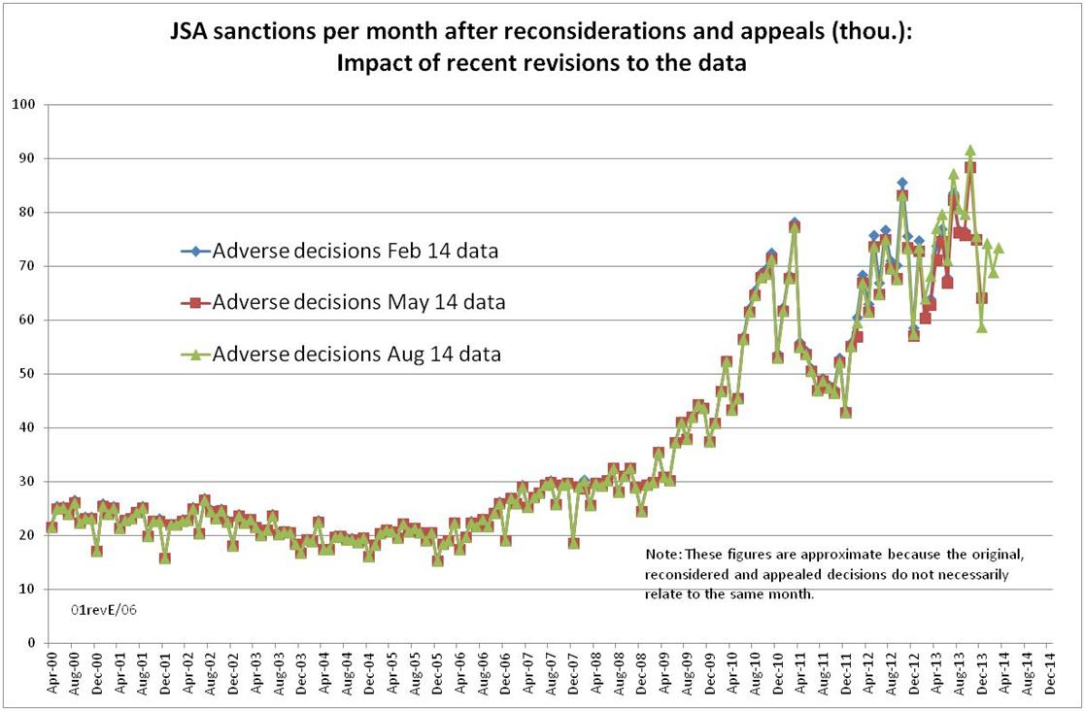

This is the fourth in a series of briefings on the DWP’s statistics on Jobseeker’s Allowance (JSA) and Employment and Support Allowance (ESA) sanctions. Earlier briefings were produced in June 2014 (for the May 2014 release), February 2014 and November 2013. They should be read in the light of the DWP’s statistical revisions, because some of their conclusions are no longer valid. However, much of the data and discussion remains useful, as noted in the present briefing. The earlier briefings are available as follows: May 2014: http://paulspicker.files.wordpress.com/2014/06/14-05-sanctions-stats-briefing-d-webster-may-2014.pdf or http://www.welfareconditionality.ac.uk/2014/03/the-great-sanctions-debate/#more-179 February 2014: http://paulspicker.files.wordpress.com/2014/02/sanctions-stats-briefing-d-webster-19-feb-2014-1.pdf, http://www.welfareconditionality.ac.uk/share-your-views/ or http://refuted.org.uk/2014/02/22/sanctionsstatistics/ November 2013: http://eprints.gla.ac.uk/90156/
I am not quoting the last quarter of 1996 because for this period there were a substantial number of cases (about 17%) still being processed under the former system.
Due to the non-inclusion in the database of the results of mandatory reconsiderations, the figures for numbers and rates of JSA and ESA sanctions after reconsideration/appeal will be slightly overestimated from December 2013 onwards. To minimise this effect, emphasis here is put on the annual figures, which are little affected. The numbers and rates of JSA and ESA sanctions before reconsideration/appeal are not affected in the same way, but are approximations for reasons discussed in the Appendix.
Published figures for the number of ESA sanctions date from October 2008 whereas those for the size of the Work Related Activity Group date only from February 2010. ESA sanction rates can therefore only be calculated from February 2010. The WRAG caseload for March 2014 has been extrapolated from the figures for Nov 2013 and Feb 2014.
For an analysis showing the lack of a coherent rationale for the Coalition’s classification of ‘failures’ into high, intermediate and low, see this author’s comments on the Policy Exchange report Smarter Sanctions, pp.5-7, available at http://www.welfareconditionality.ac.uk/2014/03/the-great-sanctions-debate/
Included here under ‘failure to participate in a training or employment scheme’ are failing to participate in the Work Programme, refusing, neglecting to avail, failing to attend, leaving or losing a place on a training/employment scheme, failing to comply with Skills Conditionality, failing to attend a Back to Work session, and failing to participate in any other training or employment scheme.

